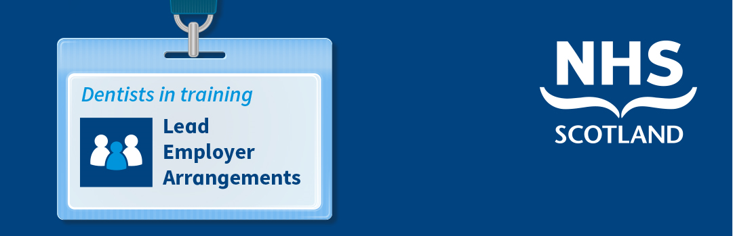

Dental Vocational Trainees - Proposed Changes to Employment

Background
NHS Education for Scotland (NES) has a pivotal role in the attraction and retention of dentists in training in Scotland, so it is important to us to always consider how we can improve their training and employment journey. NES has identified that streamlining the employment arrangements may improve the consistency of employment experience for dentists in training.
Following graduation from university, newly qualified dentists are required to satisfactorily complete a one-year programme of Vocational (Foundation) Training in an approved general dental practice or approved public dental service clinic in order to be eligible to hold a Health Board list number. NES is responsible for co-ordinating the recruitment process, co-ordinating educational agreements between trainees and trainers and processing payroll information for all Vocational Dental Practitioners (VDPs) on behalf of the Dental Training Practices. Therefore, currently dentists in vocational training are recruited and paid by NES and yet are employed by training practices.
We think there is strong justification to review these arrangements and so we are consulting with stakeholders in order to ensure we maximise the opportunities to improve the employment journey for dentists in training.

Reasons for Change
Consistent and standardised employment service/ employee relations practice:
- NES believes that moving to a single point of contact for all VDPs and Vocational Dental Therapists (VDTs) on employment issues should allow for a more standardised and efficient HR service for trainees and for other stakeholders for managing VDP and VDT employment queries and issues.
- Since 2011, NES has been the employer of trainees in General Practice and we know that this has improved the consistency of experience for doctors in training and provided the host practice with additional support for any HR issues that may arise during the placement.
- NES already have tested policies, systems and processes in place which can be adopted and aligned to the needs of VDPs and VDTs, this includes supporting more complex areas that can arise during the vocational training year including for example sickness absence, maternity leave, paternity leave and conduct issues.
Consistent application of NES employment policies to all VDPs and VDTs ensures a fair and equitable approach can be applied where there are any employment issues. Closer NES involvement in supporting trainees with employment issues may also allow for earlier recognition and resolution of any problems.
Clarification of employment responsibilities and mitigation of risk:
- Currently trainees are employed by individual training practices, however NES is often asked to provide advice to practices when there are employment related queries pertaining to trainees.
- NES cannot provide full support to such cases at present as we are not the employer and to do so creates further ambiguity and risk around employment liabilities.
The direct employment by NES of the dental trainees would mean that all trainees follow the same policies. NES would be able to provide greater support to host practices applying the policies to trainees on employment issues, utilising the established HR expertise and infrastructure in the organisation, and enabling the practice to focus on delivering a high-quality training experience.
Maximising Digital Solutions:
Employment related administration is time consuming for all those involved and can often lead to duplication of effort in providing similar information several times as trainees move through training and employment.
- Turas People is an application which has been designed to better join up the training and employment journey and enables trainees to store their employment related information in one place.
- It provides pre-employment information (with progress tracking and alerts) and supports issuing electronically employment related documentation, including payroll forms, occupational health pre employment assessments and contracts of employment.
Alignment to the training journey
- After the initial year in dental vocational training, several dentists in training continue with their training in either the hospital or public dental services. Work is being progressed for these dentists to have a lead employer for the duration of their training programme to reduce the number of employers encountered during the training journey. The lead employer model has significantly reduced the duplication of employment administration for doctors in training and is being extended to dentists in training from August 2022. Further information on the lead employer arrangements are available on the Turas Hub: https://hub.nes.digital/lead-employer-arrangements/.
- NES is already involved in the training programme management of dentists in training. NES employment of the dentists in training during their vocational training may improve the joining up of support available to dentists in training who encounter any difficulties during the training journey.

How does this affect me?
Vocational Trainees: The change would mean that all Vocational Dental Trainees starting in post in August 2022 would be employed by NES as opposed to a Dental Training Practice. There would be no change to the delivery of the recruitment, onboarding and payroll processes as they are already delivered by NES. It would however mean that all Vocational Trainees across NHS Scotland would follow the same policies and procedures and have access to support from NES HR for any employment related matters.
Vocational Trainers: The change in employment would mean that Vocational Dental Trainers would have support from NES HR, ensuring that fair and equitable employment processes are applied. There would also be administrative efficiencies in relation to information sharing between NES and Dental Training Practices. Work will be progressed with Scottish Government so that the vocational dental practitioners can continue to work under their trainer’s list number, subject to the existing conditions.

What happens now?
NES would like to work together with stakeholders to progress this work and implement the proposed changes to the employment arrangements of VDPs and VDTs for August 2022. NES would therefore welcome any feedback on the proposed changes from all stakeholder groups. Please send any feedback to nes.lead.employer@nhs.scot.

