DOCTORS IN TRAINING INDUCTION

Induction Booklet

Item | Page
NHS Highland Operational Units | 3
Welcome to NHS Highland | 4
Medical Staffing – About Us | 5
Medical Staffing – Contact Information | 6/7
Departmental Contacts – Raigmore Hospital, Inverness | 7/8
Departmental Contacts – New Craigs Hospital, Inverness | 8
Departmental Contacts – Belford Hospital, Fort William | 8
Departmental Contacts – Caithness General Hospital, Wick | 8
Departmental Contacts – Argyll & Bute CHP | 9
Departmental Contacts – Corporate Services | 9
NHS Education for Scotland Contacts | 10
Support Networks for Junior Doctors | 11
Annual Leave Entitlement | 12
Public Holiday Entitlement | 13
Study Leave | 14
IDL Med 3 Form | 15
Mandatory Courses | 16/17/18
General Medical Council | 19
Immigration | 20
Payroll & Travel | 21
Facilities (Accommodation and Catering) | 22
Sickness Absence Reporting | 23/24
Improving Working Lives - PIN Policies Occupational Health | 25
New Deal for Doctors in Training | 26/27/28/29
The Palliative Care Advisory Service (PCAS) | 30
Overseas Patient Guidance | 31
RAIGMORE HOSPITAL
Raigmore Hospital Zone Directory/Map | 33
Facilities (Sports and Social Club) | 34/35
Hospital at Night – Applicable to each area | 36/37/38/39
Laboratory System | 40/41
Pharmacy Information | 42

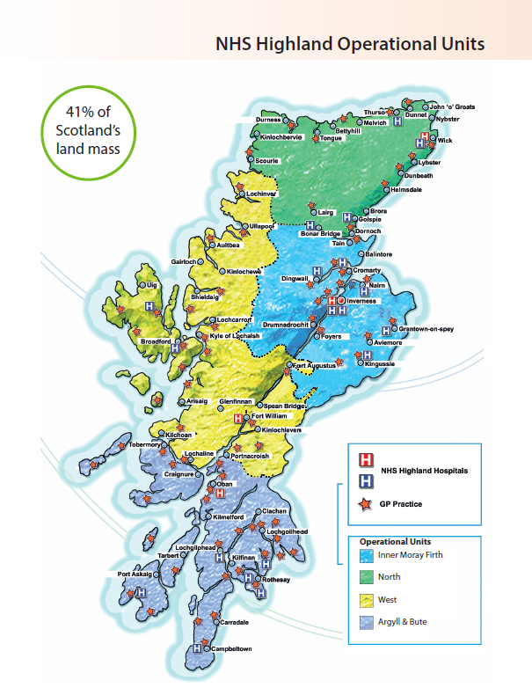

Welcome to NHS Highland

NHS Highland welcomes you to your new post. This booklet is designed to inform you of the various issues you should be aware of during your placement.

NHS Highland as your placement board is committed to offering you the fullest support to enable you to fulfil your role to the best of your ability.

NHS Highland – A patient safety Board

Within NHS Highland the safety of patients is paramount; we hope that you will experience that culture whilst working here.

Incident reporting is one of the key methods used by NHS Highland to identify issues that, may pose a serious risk to patients or staff. Therefore we ask all staff working in NHS Highland to alert us to concerns of patient safety, or of errors or near misses that have occurred via the DATIXweb DIF1, this system is easily accessed via the intranet. As an organisation if we do not know of errors or safety issues then we can not respond.

The clinical governance and risk team are here to support you and will feedback to you on issues that are raised.

The Scottish Patient Safety Programme

As with all NHS SCOTLAND Boards we participate in the Scottish Patient Safety Programme, the aim of the programme is to help put evidence based care into practice.
Examples you will see are how we insert and monitor peripheral cannulas and central venous cannulas, reconciling medications of all patients on and during their admission, and the use of the early warning score to identify patients who are becoming more unwell. This list is not exhaustive!
We are happy to support your learning on these interventions when you start work in the Board and we ask you to inform us as soon as is possible of areas of practice you would like support in.
When working on the wards if you participate in the activities of the safety programme, audit or helping test a change you can use this in your e portfolio.

Medical Staffing – About Us

The Medical Staffing Department is situated in Raigmore Hospital, Inverness (Zone 6, Office Suite 4) and is the focal point for all matters relating to Hospital Medical and Dental staff across NHS Highland. The Raigmore office provides a service to managers and staff at the following hospitals within the NHS Highland area:-

- Raigmore Hospital, Inverness
- New Craigs Hospital, Inverness
- Belford Hospital, Fort William
- Lorn & Islands Hospital, Oban
- Caithness General Hospital, Wick*
- Argyll & Bute Hospital, Lochgilphead
- McKinnon Memorial Hospital, Broadford, Isle of Skye
- Cowal Community Hospital, Dunoon
- GP Practices in the South East CHP, Mid Highland CHP, Argyll & Bute CHP

* There is a small Medical Staffing section within the Personnel Department based in Caithness General Hospital, Wick which deals with substantive and locum recruitment for doctors working in the North Highland CHP which includes Caithness General Hospital in Wick and is overseen by the Medical Staffing Manager.

Responsibilities of the Medical Staffing Team:

- Recruitment of Hospital Medical & Dental staff
- Recruitment of Locum Hospital Medical & Dental staff
- Co-ordinate Recruitment of Diagnostic specialties for Scottish Medical Training
- Junior Doctors New Deal (monitoring and design of rotas)
- Working Time Regulations
- Junior Doctors Induction
- Consultant Contract – Job Planning and Enhanced Appraisal & Revalidation.
- Associate Specialist & Specialty Doctor contract
- Award of Discretionary Points
- Relocation & removal expenses
- Expenses (excluding expenses for undertaking clinics)
- Workforce Planning
- Advice on Terms and Conditions of Service for Hospital Medical and Dental staff.

Further info can be found on the Medical Staffing page on the intranet - http://intranet.nhsh.scot.nhs.uk/org/corpserv/humanresources/employmentservices/medicalstaffing/Pages/Default.aspx

MEDICAL STAFFING - CONTACT INFORMATION
Jackie Sutherland  Medical Staffing Manager | Tel: | 01463 705670 (x5670)
 | Email: | Jackie.Sutherland@nhs.net
Maria Rose  Deputy Medical Staffing Manager | Tel:  Email: | 01463 704451 (x4451)  Maria.rose3@nhs.net
Carleen Gordon  Senior Medical Staffing Officer  Consultant Contract & Senior Medical Staff Appraisal and Revalidation | Tel:  Email: | 01463 706013 (x6013)  Carleen.gordon@nhs.net
Leah Morrison  Senior Medical Staffing Officer  Consultant Contract & Senior Medical Staff Appraisal and Revalidation | Tel: | 01463 705099 (x5099)
 | Email: | Leah.morrison@nhs.net
Amy MacRae  Senior Medical Staffing Officer  Consultant Contract & Senior Medical Staff Appraisal and Revalidation | Tel:  Email: | 01463 704699 (x4699)  Amy.macrae2@nhs.net
Sara Palmer  Senior Medical Staffing Officer  Paediatrics, Obstetrics & Gynaecology, Clinical Services & Support , North & Mid Highland OU & Argyll & Bute CHP | Tel: | 01463 704411 (x4411)
 | Email: | sara.palmer4@nhs.net
Lauren Baird  Senior Medical Staffing Officer  Medical, Cancer Services, Corporate Services, South OU | Tel: | 01463 704450 (x4450)
 | Email: | lauren.baird@nhs.net
Fareedah Ewen  Senior Medical Staffing Officer  Surgical & Anaesthetics, West & Mid Highland OU, Rural Fellows | Tel: | 01463 706524 (x4551)
 | Email: | fareedah.ewen@nhs.net
Ruth Grant  Medical Staffing Officer  Paediatrics, Obs & Gynae, Clinical Services & Support , North & Mid Highland OU, Argyll & Bute CHP | Tel: | 01463 706526 (x6526)
 | Email: | ruth.grant3@nhs.net
Laura Rodgers  Medical Staffing Officer  Medical, Cancer Services, Corporate Services, South OU | Tel: | 01463 705653 (x5653)
 | Email: | laura.rodgers@nhs.net
Hannah Clapton  Medical Staffing Officer  Surgical & Anaesthetics, West & Mid Highland OU, Rural Fellows | Tel: | 01463 705551 (x5551)
 | Email: | hannah.clapton@nhs.net

MEDICAL STAFFING, CAITHNESS GENERAL HOSPITAL - CONTACT INFORMATION
Jasmine Oag  Employment Services Manager | Tel:  Email: | 01955 880404  jasmine.oag@nhs.net
Pauline MacDonald  Employment Services Officer |  | 01955 880405  Pauline.macdonald1@nhs.net
We expect you to make contact with your Service Leads and Rota Masters

DEPARTMENTAL CONTACTS – RAIGMORE HOSPITAL
Department | Service Lead | Rota Master | Comments
Accident & Emergency | Andrew Rowlands  a.rowlands@nhs.net | Mike Rennie  Michael.rennie@nhs.net | Please contact Secretary Amanda Hume. Tel: 01463 704358; Email Amanda.Hume2@nhs.net
Anaesthetics | Michael Duffy  mikeduffy@nhs.net | Michael Duffy  mikeduffy@nhs.net | Please contact Secretary Morag Ritchie. Tel 01463 705350; Email Morag.Ritchie@nhs.net
ENT | Angus Cain  Angus.Cain@nhs.net | Angus Cain  Angus.Cain@nhs.net
General Medicine |  | Will Rutherford  William.rutherford1@nhs.net | Please contact Secretary Marina Simpson  Tel - 01463 706321  Email – marina.simpson@nhs.net
General Practice | Please contact Practice Direct
General Surgery | Mike Lim  Michael.lim2@nhs.net | Middle Grade:  Jennifer.pollard2@nhs.net  FY1: Ian Daltrey  Ian.Daltrey@nhs.net
Haematology/Oncology | Participating in the General Medicine Jnr MG rota | Will Rutherford  William.rutherford1@nhs.net | Please contact Secretary Marina Simpson  Tel - 01463 706321  Email – marina.simpson@nhs.net
Obstetrics & Gynaecology |  | FY2/GPST: Aik Goh  aik.goh@nhs.net  Middle Grade : Keri McCully  Keri.mccully@nhs.net
Ophthalmology | tbc | Simon Hewick  Simon.hewick@nhs.net
Orthopaedics | William MacLeod  w.macleod@nhs.net | Alastair Faulkner  a.faulkner1@nhs.net  FY1: James Simpson  James.simpson3@nhs.net
Paediatrics | David Goudie  david.goudie2@nhs.net | Alan Webb  Alan.Webb2@nhs.net
Pathology | Mark Ashton  Mark.Ashton@nhs.net
Radiology | Alistair Todd  alistair.todd@nhs.net | David Eason  David.eason@nhs.net
Urology | Mike Lim  Michael.lim2@nhs.net | Thierry Bonnin  Thierry.bonnin@nhs.net

We expect you to make contact with your Service leads and Rota Masters

DEPARTMENTAL CONTACTS – NEW CRAIGS HOSPITAL, INVERNESS
Department | Clinical Lead | Rota Master | Comments
Psychiatry | Nikki Thomson  nikki.thomson2@nhs.net | David Gordon  David.Gordon3@nhs.net

DEPARTMENTAL CONTACTS – BELFORD HOSPITAL, FORT WILLIAM
Department | Clinical Lead | Rota Master | Comments
Accident & Emergency | Brian Tregaskis  B.Tregaskis@nhs.net | Patrick Byrne  Patrick.byrne@nhs.net
General Medicine
General Surgery

DEPARTMENTAL CONTACTS – CAITHNESS GENERAL HOSPITAL, WICK
Department | Clinical Lead | Rota Master | Comments
General Medicine | Paul Davidson  Paul.davidson@nhs.net | Jasmine Oag  Jasmine.oag@nhs.net | Please email Jasmine Oag for any rota information.
General Surgery

DEPARTMENTAL CONTACTS – ARGYLL & BUTE CHP
Department | Clinical Lead | Rota Master | Comments
General Medicine, Oban |  | Colin Millar  colin.millar@nhs.net  Nicky Campbell (Associate Specialist)  Nicky.Campbell@nhs.net | Please email Dr Colin Millar and Dr Nicky Campbell regarding the rota.
General Surgery, Oban
Psychiatry, Lochgilphead | Tammy Burmeister  tammy.burmeister@nhs.net | Fiona Broderick (PA to Clinical Lead)  Fiona.Broderick@nhs.net | Please email Fiona Broderick regarding the rota.

DEPARTMENTAL CONTACTS – CORPORATE SERVICES
Department | Clinical Lead | Rota Master | Comments
Occupational Health | Mark Hilditch  Mark.hilditch@nhs.net
Public Health | Hugo Van Woerden  Hugo.vanwoerden1@nhs.net | Ken Oates  Ken.Oates@nhs.net

NHS Education for Scotland (NES) Contacts

NES contacts are available for you to contact them.

- Northern Deanery Associate Postgraduate Dean’s based in Inverness

Mr Bill McKerrow, Associate Postgraduate Dean, william.mckerrow@nhs.net

Secretary Anne Bell on 01463 255734 or email anne.bell1@nhs.net

- Inverness: Raigmore Hospital and New Craigs Hospital

Foundation Programme Directors:

Dr Alastair McDiarmid, Anaesthetics, Aberdeen, amcdiarmid@nhs.net

Mr William MacLeod, Orthopaedics, Raigmore w.macleod@nhs.net

Mel Stewart, Hospital Training Administrator, melanie.stewart@nes.scot.nhs.uk
01463 255704 (7704 internal)

- Lorn & Islands Hospital, Oban

Emma MacDonald, Postgraduate Administrator emma.macdonald@nhs.net 01631 789021

- Belford Hospital, Fort William

Janet Shepherd, Postgraduate Administrator janet.shepherd2@nhs.net 01397 707413

- Caithness General, Wick

Larissa Spindler, Training Programme Assistant, larissa.spindler@nes.scot.nhs.uk
01224 554960

- Aberdeen NES Office

Larissa Spindler – Larissa.Spindler@nes.scot.nhs.uk 01224 805133
Dianne Morrison, Training Programme Team Lead Dianne.morrison@nes.scot.nhs.uk 01224 805131
Kim Walker, Education Director, kim.walker@nes.scot.nhs.uk 01224 553859

Support Networks for Junior Doctors

Contact | Telephone Number
Accommodation (Raigmore) Maggie Melrose | 01463 704350
Accommodation (Belford) Janet Shepherd | 01397 880270
Accommodation (Caithness) Pauline Macdonald | 01955 880405
Accommodation (Lochgilphead) Fiona Broderick | 01546 604908
Accommodation (Oban) Suzanne Frood | 01631 567500
Chaplaincy (Highland) | 01463 704463
Childcare Voucher Scheme | 0845 330 4433
Citizens Advice Bureau | 08444 994 111 (advice) / 01463 237 664
Director of Medical Education – Dr Emma Watson | 01463 255704
eHealth Service Desk (Highland) | 01463 704999
eHealth Service Desk (Lochgilphead) | 01546 605640
eHealth Service Desk (Oban) | 01631 788941
General Medical Council | 0845 357 0020
General Practice – Registration with Local Practice | 01463 706820
Medical Director – Dr Roderick Harvey | 01463 704936
Medical Staffing | 01463 705099
National BMA offices Scotland BMAScotland@bma.org.uk | 0131 247 3000
NHS Education for Scotland (NES) | 01463 255000
Occupational Health (Highland) | 01463 704499
Occupational Health (Argyll & Bute) | 01546 605685
Payroll | 01463 704890
Personnel – Caithness General Hospital | 01463 706849 /  01955 605050
Personnel – Belford Hospital – Aileen Dewson | 01397 702481
Personnel – Psychiatry, Inverness – Yvonne Morrison | 01463 706850
Personnel – Argyll & Bute – Angela Dewsnap | 01546 605686
Personnel – Raigmore- Medical & Diagnostic Specialties  - Catherine MacKay | 01463 706864
Personnel – Raigmore – Surgical Specialties – Jill Davidson | 01463 706853
Finance for Relocation Enquiries – Elaine Buchan | 01463 704884

Annual Leave Entitlement

Entitlement – FY1’s and FY2’s are entitled to 25 days annual leave and 10 days public holidays per annum. To ensure equal split of leave between specialties please find below your entitlement for each 4 month period (including all public holidays).

FY1’s  FY2’s | 24 July 2018 – 4 Dec 2018 = 11 days leave (inclusive of Public Holiday on 6 August and 19 October)  1 August 2018 – 4 Dec 2018 = 10 days leave (inclusive of Public Holiday on 19 October)
 | 5 Dec 2018 – 2 April 2019 = 12 days leave (inclusive of Public Holidays on 25/26 December and 01/02 January 2019
 | 3 April 2019 – 6 August 2019 = 13 days leave (inclusive of Easter dates, May Date and July date 2019)
StR’s / GPST’s / FTSTA’s / SpR’s
(Salary point 00; 01 or 02)
 |  | 4 months |  | 9 days / 8 days / 8 days
 |  | 6 months |  | 12.5 days
 |  | 12 months |  | 25 days
StR’s / SpR’s
(Salary point 03 or higher)
 |  | 4 months |  | 10 days
 |  | 6 months |  | 15 days
 |  | 12 months |  | 30 days

Annual Leave Card

It is your responsibility to find out the management/approval arrangements with each placement for your annual leave.

It is your responsibility to manage your annual leave over the period of your contract. Do not accumulate your entitlement for the last month of your contract.

If you do not take your annual leave entitlement prior to your termination date (unless there are exceptional circumstances) the Board will not make a payment for this annual leave.

***Rotational Doctors – please note that you are not entitled to transfer any outstanding annual leave entitlement from your main base to NHS Highland and vice versa.

Annual Leave is included within the majority of Rotas, please discuss with your Service Lead if you have queries.

For further information on Annual Leave, refer to the Annual Leave Policy, available on the intranet.

Public Holiday Entitlement

Please note that you are entitled to the public holidays that fall during your period of placement. The public holiday is either to be worked (with a day off in lieu) or taken as leave. This must be recorded on your annual leave card.

All FY1s in Raigmore and FY2s in Mixed Specialties
Unless expressly told by your department, it is assumed that if you are rostered to work on a public holiday you will be at work. If you work on 25 or 26 December, 1 or 2 January or on Good Friday you are entitled to claim the day back in lieu. All other public holidays have already been included in your leave allocation of 10 days per rotation. The date of claiming the day back in lieu is to be discussed between the department and the individual trainee.

NHS Highland H&SCP (excluding Argyll & Bute H&SCP):

Friday, 30th March 2018 (Good Friday)
Monday 2nd April 2018 (Medical and Dental staff only)
Monday, 7th May 2018 (Early May Bank Holiday)
Friday 6th July 2018 (Medical and Dental Staff only)
Monday, 6th August 2018 (Summer)
Friday, 19th October 2018 (Autumn)
Tuesday, 25th December 2018 (Christmas)
Wednesday, 26th December 2018 (Christmas)
Tuesday, 1st January 2019 (New Year)
Wednesday, 2nd January 2019 (New Year)

For Argyll & Bute Body Corporate (Health staff)

Friday, 30th March 2018 (Good Friday)
Monday, 2nd April 2018 (Easter Monday)
Monday, 7th May 2018 (Early May Bank Holiday)
Monday 14th May 2018 (Medical and Dental staff only)
Monday 9th July 2018 (Medical and Dental staff only)
Monday, 24th September 2018 (Autumn)
Tuesday, 25th December 2018 (Christmas)
Wednesday, 26th December 2018 (Christmas)
Tuesday, 1st January 2019 (New Year)
Wednesday, 2nd January 2019 (New Year)

Study Leave

FY1’s are not entitled to any Study Leave, although they are required to attend a 1 hour mandatory teaching session every week. This is supplemented by ward based teaching throughout the year. For more information, please contact Mel Stewart on 01463 255704.

Study Leave for FY2’s and StR’s is completed by NES through Turas – individual log ins and further information on the study leave process will be produced by NES at induction.

IDL Med 3 form

A change to the Immediate Discharge Letter system to accommodate a new field to record whether or not a Med 3 Form (Statement of Fitness for Work) has been issued to the patient. This will help to maintain effective communication with primary care. The new field comprises a mandatory simple drop down selection list together with an optional comments box which should be used to summarise the advice stated on the Med3 form if it has been issued.

The relevant new fields are shown below

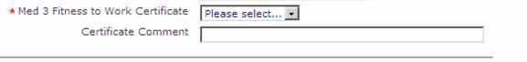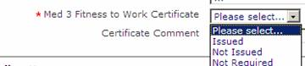

Within Raigmore Hospital Med 3 forms are now available in all wards.

Please click to follow this link fitnote-hospital-guide.pdf for a short guidance leaflet on the use of the forms, which includes a sample form. In particular the following points should be noted
- Certification of sickness for the duration of an inpatient stay should continue to be made using a Med 10 form. These are available on the wards and can be completed at the request of the patient by clerical staff. This form simply certifies that the patient was an inpatient and states the relevant duration.
- Where at the time of discharge from hospital, or following an outpatient or A&E consultation it is anticipated that the patient will be fit to return to work within seven calendar days there is no need to complete a Med 3 form as the patient can self certify in the interim.
- If it is expected that the patient will be unfit for normal work for more than seven days following a consultation or discharge from hospital then a Med 3 form should be completed if requested or required by the patient.
- The Med 3 form must be completed by a doctor, but there is no restriction on their type of registration (full or provisional).

Statutory and Mandatory Courses

Course Name | Frequency | Delivery method | Duration
STATUTORY & MANDATORY: This list is to be read in conjunction with the Statutory & Mandatory Prospectus.
Fire safety
Highland: Fire Safety | Within 1 month of starting placement then every 2 or 3 years depending on care environment | Computer Based Training | 1 hour
Generic Fire Training | Within 12 months of starting in role then every year for staff working in high risk patient/client environment where there are sleeping facilities¹ | Instructor Led | 1 hour
Moving and Handling Training
People Handling (Module A) | Within 3 months of starting in role then every year thereafter | Computer Based Training | 1.5 hours
Minimal People Handling (Modules B and C) | Within 3 months of starting in role (those who assist people to move as part of their role) | Instructor Led | 3.5 hours
Violence and Aggression
Theory and Breakaway | Within 3 months of starting in role | Instructor Led | 1 day
Theory and Breakaway Refresher | Every 2 years thereafter (all staff except those who work in Inpatient Mental Health) | Instructor Led | 4 hours
Mental Health Restraint | Within 3 months of starting in role (only those who work in Inpatient Mental Health setting) | Instructor Led | 3 days
Mental Health Restraint Refresher | Every Year (only those who work in Inpatient Mental Health setting) | Instructor Led | 3 days
Adult Support and Protection
Introduction to Adult Support and Protection (level 1) | Within 3 months of starting in role then every 3 years thereafter | Instructor Led or Computer based training | 3 hours
Adults with Incapacity Training | Within 3 months of starting in role then every 3 years thereafter | Instructor Led or Computer based training | 1.5 hours
Child Protection
Child Protection  (Level 2- 5 Programmes apply) | Varies with course and role | Instructor Led | Varies with course and role
Equality and Diversity
Equality and Human Rights | Within 3 months of starting in role and every 3 years thereafter | Computer based training | 1 hour
Blood Transfusion
Safe Transfusion Practice (Module 1) | Within 3 months of starting in role then every 2 years thereafter | Computer based training and Instructor led | 1 hour
Gender Based Violence
Understanding Violence against Women (Level 1) | Within 3 months of starting in role  (Staff in the following categories : GPs, A&E, Maternity, Mental Health, Sexual Health i.e. staff who work with women who may be at risk of abuse or violence) | Instructor Led | 0.5 day
Understanding Violence against women (Level 2) | Within 3 months of starting in role  (Staff in the following categories : GPs, A&E, Maternity, Mental Health, Sexual Health i.e. staff who work with women who may be at risk of abuse or violence) | Instructor Led | 0.5 day
Infection Control
HAI Induction Programme (Clinical) | Within 3 months of starting in role | Computer based training | 1 hour
Principles of Aseptic Technique | Within 6 months of starting in role | Computer based training | 1 hour
The Prevention & Management of Occupational Exposure (previously called Needle Stick Injury) | Within 3 months of starting in role then every 3 years thereafter | Computer based training | 1 hour
Information Governance
Safe Information Handling - Foundation | Within 3 months of starting in role | Computer based training | 1 hour
Resuscitation
Immediate Life Support (ILS)  (FY1s) | Within 1 month of starting in role if this was not completed in Medical School or within 12 months for those who did have ILS certificate from Medical School. | Instructor led | 6 hours / 3 hours
Advanced Life Support (ALS)  (FY2s +) |  | Instructor led
OTHER TRAINING:
Death Certification |  | Computer based training | 1 hour
Hand Hygiene |  | Computer based training
Antibiotic Prescribing: todays practitioners |  | Computer based training
Clostridium difficule clinical services |  | Computer based training
Clostridium difficule online tutorial |  | Computer based training
Introduction to Patient Safety |  | Computer based training
Quality Improvement Programme |  | Computer based training
Patient Safety: National Early Warning System (NEWS) | within 3 months of starting in role then every year thereafter | Instructor Led | 45 minutes
Patient Safety: Paediatric Early Warning System (PEWS) | within 3 months of starting in role then every year thereafter | Instructor Led | 45 minutes

General Medical Council

The Good Medical Practice guidance describes what is expected of all doctors registered with the GMC. “It is your responsibility to be familiar with Good Medical Practice and to follow the guidance it contains. It is guidance, not a statutory code, so you must use your judgement to apply the principles to the various situations you will face as a doctor, whether or not you hold a licence to practise and whether or not you routinely see patients. You must be prepared to explain and justify your decisions and actions.”

“You must keep your knowledge and skills up to date throughout your working life. You should be familiar with relevant guidelines and developments that affect your work. You should regularly take part in educational activities that maintain and further develop your competence and performance.”

“You must keep up to date with, and adhere to, the laws and codes of practice relevant to your work.”

For further information please access this link;

http://www.gmc-uk.org/guidance/good_medical_practice.asp

Whilst in placement in NHS Highland if your GMC status changes at any point you must notify Medical Staffing. Please ensure your registration is kept up to date and the GMC are notified of any change of address, bank details if you pay by direct debit etc. If you have any queries, please contact Medical Staffing to discuss.

Immigration

In your appointment pack you were requested to provide confirmation of your Immigration Status. If you hold a non British or EEA Passport, you must have valid immigration status to work in the UK for the duration of the post.

Whilst on placement in NHS Highland if your Immigration Status changes at any point you must notify Medical Staffing. Please ensure your Immigration is kept up to date and the Home Office – UK Border Agency is notified of any change of address etc.

Although it is primarily the individual’s responsibility, if you are in a training programme NHS Education for Scotland will contact you 3 months prior to your Immigration expiry date, to remind you to renew your status. If you are in a non training post Medical Staffing will contact you.

If you have any queries, please contact Medical Staffing to discuss.

Payroll & Travel Information

Travel Claim Forms - Clinics
If you are travelling to Clinics without a Senior Medical Staff Member you must use a separate claim form. Do not include this information on your Relocation Claim Form.

Travel Claim Forms for Clinics can be authorised by the Service Manager. The expenses forms require to be sent to Medical Staffing in order to be processed. These payments will be paid separately from your pay into bank account.

Expenses Claim forms can be found on the Intranet at the following link.
http://intranet.nhsh.scot.nhs.uk/FormsLibrary/Documents/Travel%20Claim%20Form%20-%20Hospital%20Medical%20and%20Dental%20Staff%20(Written).xls

Locum Claim Forms
If you cover any shifts as a locum, please complete a Locum Claim Form and obtain authorisation from the Service Lead and General Manager then submit to Medical Staffing for processing.
Locum Claim forms can be found on the Intranet at the following link:
http://intranet.nhsh.scot.nhs.uk/FormsLibrary/Pages/Default.aspx

Opt out form
This form should be completed if you undertake any extra shifts which take you over 48 hours. This form only needs to be signed once and it offers legal protection for the duration of your placement with NHS Highland. It should not be used to access training opportunities.

Facilities
- Accommodation
Enquiries regarding accommodation on:

  - Raigmore Hospital, Inverness should be addressed to the Accommodation Department on 01463 704343 or email them at high-uhb.raigmoreaccommodation@nhs.net .
  - Caithness General Hospital, Wick should be addressed to Pauline MacDonald on 01955 880405
  - Belford Hospital, Fort William should be addressed to Janet Shepherd, Personnel Department on 01397 702481.
  - Argyll & Bute Hospital, Lochgilphead should be addressed to Fiona Broderick, Personnel Department on 01546 604908.
  - Lorn & Islands Hospital, Oban should be addressed to Suzanne Frood, Accommodation Department on 01631 788 948.

A list of charges will be available on request.

- Catering
Raigmore Hospital has its own restaurant which is open to all staff, patients, visitors and the general public. The Blue Dolphin restaurant offers a wide range of hot and cold meals, snacks, sandwiches and refreshments served throughout the day. The restaurant is located on the Yellow Corridor and is clearly signposted throughout the hospital.
Restaurant Information
Raigmore Hospital | Location | Opening Times
The Blue Dolphin Restaurant | Yellow Corridor  Ground Floor | Monday - Friday  08.00 - 11:00  12:00 - 14:00  15:00 - 16:30  17:00 - 19:00  Saturday & Sunday  07:30 - 11:00  12:00 - 14:00  15:00 - 16:30  17:00 - 19:00
Main Entrance Buffet Bar and vending machines | Main Entrance  Ground Floor | Monday - Friday  09:30 - 20:15  Saturday & Sunday  12:00 - 17:00
Outpatients Tea Bar | Outpatients Tea Bar  Ground Bar | Monday - Friday  09.30 - 16.00
Centre for Health Science | Centre for Health Science Building, Raigmore Hospital | Monday - Friday  09.00 - 16.30

Sickness Absence Reporting

Employee Responsibility

If you are unable to attend work or fall ill during a period of leave, you are responsible for telling your manager or confirming your manager is aware at the earliest opportunity before your scheduled starting time.

Contacting your manager by telephone is seen as one of the quickest methods, but NHS Highland recognises that communication in other formats may be preferable based on individual needs.

It is your responsibility to make contact with your manager or other senior member of staff. Only in exceptional circumstances where you are unable to make contact personally or through another appropriate format, a relative or friend may make contact on your behalf, but the responsibility remains with you. Where your manager is not available, it is essential that contact is made with an alternative senior member of staff who will be responsible for taking the information and passing it to the manager. Telephone messages should not be left on voice mail, with the switchboard or with other wards or departments, unless previously agreed as a reasonable adjustment.

Employees should be aware that if they do not meet the requirement to make contact as above action may be taken through the Management of Employee Conduct policy.
It is important that you communicate all relevant details when making contact, including estimated duration of absence. Such information will be kept in line with the Data Protection Act 2018.

At this stage, you should agree with your manager when you should get in touch again and if appropriate when a medical certificate must be submitted.

It is your responsibility as stated to keep your manager informed of your progress.

If your sickness is more than seven calendar days, you are required to submit a medical certificate from your doctor for each period of sickness absence and send it to your manager. Delays in submitting a medical certificate may result in pay being temporarily withheld.

If you fall ill at work or have to go home due to sickness, you should advise your manager or another senior member of staff before leaving.

PLEASE INFORM YOUR SERVICE LEAD WHEN OFF SICK

Sickness Absence Reporting

Notification Requirements

Absence of 1-3 Calendar Days

Neither a self-certificate nor a medical certificate is required. However, the absence record form should be completed on return to work.

Continued Absence of 4-7 Calendar Days

On the fourth day of your absence you (or in exceptional circumstances, someone on your behalf) must telephone your manager or deputy and advise of the further duration of your absence. A self certification form is available from your manager and should be completed on your return to work. If you have a medical certificate from day one, no self certification will be required, because a medical certificate supersedes self certification.

Continued Absence Lasting 8 Calendar Days or more

You (or in exceptional circumstances, someone on your behalf) are required to contact your manager as soon as possible to advise of the approximate duration of your absence based on medical advice and obtain from your General Practitioner (GP) a medical certificate to cover the extended period. (You will be required to complete and return a self-certificate which covers you for the first seven days of absence). The medical certificate should be sent as soon as possible, to your manager. You must continue to submit medical certification thereafter until you return to work covering the sickness absence period.

Actions resulting from non-notification

Employees should be aware that if they do not meet the requirements as above action may be taken through the Management of Employee Conduct policy.

If you would like further information, please refer to the Promoting Attendance Policy, available on the intranet or by this link.
http://intranet.nhsh.scot.nhs.uk/PoliciesLibrary/Pages/Default.aspx

Occupational Health

NHS Highland is committed to the health and well-being of it’s' staff. Healthy and well staff makes for excellent patient care. Occupational Health works to deliver this aim, with a wide range of services to help protect staff from hazards of their work and to support staff with health problems to continue at, or return to, their work. Occupational Health recognises the benefits of work on health. We also assist NHS Highland in meeting its legal requirements under Health and Safety, Employment and Disability legislation.
Our team consists of consultant occupational physicians, occupational health nurses, rehabilitation specialists (physiotherapy, cognitive behavioural therapy, occupational therapy) and an admin team. Services are delivered across NHS Highland. Occupational Health is part funded by service provision to neighbouring NHS Boards, public organisations and private business. This allows an enhanced service to be provided to NHS Highland staff while having a significant positive impact on the public health of the working age population in the Highlands.

If you would like further information, please refer to the Occupational Health page available on the intranet or by this link.
http://intranet.nhsh.scot.nhs.uk/Organisation/HumanResources/OccupationalHealth/Pages/Default.aspx

New Deal for Doctors in Training

If you wish to discuss your rota shifts please contact the nominated Departmental Representative. Please do not swap any shifts with your colleagues, you must approach the nominated Departmental Representative to discuss and obtain authorisation. When covering Night Shift it is unacceptable to complete Day Time work during the Night, if you feel this occurs, please report this to the Medical Staffing Department.

Monitoring of rotas is a contractual obligation of both NHS Highland and all Doctors in Training. The job descriptions, letters of appointment and contracts of Doctors in Training specifically mention their contractual obligation to monitor hours on request. This Monitoring System identifies the roles and responsibilities of those involved in achieving and retaining compliance in relation to the New Deal for Doctors in Training.

A period of monitoring will be scheduled in the 6 month period - August to February and February to August. NHS Highland is required to undertake Monitoring of Rotas every 6 months.

The Medical Staffing Department coordinates the monitoring process.

A nominated rota representative is required from each department; if you are interested please contact the Medical Staffing Team to discuss further.

If you would like any further information on the monitoring process, please request a copy of NHS Highland’s Doctors in Training New Deal Monitoring Rotas for Compliance Policy, from Medical Staffing.

Working Time Regulations for Doctors in Training

The Working Time Regulations for Junior Doctors was enforced on the 1st August 2009 to ensure all Junior Doctors work an average of 48 hours over 26 weeks.

It is your own responsibility to monitor your hours to ensure they remain within 48 hours over 26 weeks. NHS Highland expects all Junior Doctors to comply with the Working Time Regulations for Junior Doctors.

The Working Time Regulations Policy is available from the medical staffing department.

Please read through the New Deal vs. Working time Regulations Document which outlines the differences between the regulations.

DIFFERENCES BETWEEN NEW DEAL AND WORKING TIME REGULATIONS
HOURS OF WORK AND REST REQUIREMENTS COMPARISON
New Deal |  |  |  | Working Time Regulations
Maximum contracted hours for each working pattern |  |  |  | Maximum contracted hours for each working pattern |  |  | 2004 |  | 2007 | 2009
On-call rotas: 72 hours per week |  |  |  | On-call rotas (resident) |  |  | 58 |  | 56 | 48
 |  |  |  | (non-resident) |  |  | 72 |  | 72 | 72
Partial shifts and 24 hour partial shifts: 64 hours per week |  |  |  | Partial shifts and 24 hour partial shifts: |  |  | 58 |  | 56 | 48
Full shifts: 56 hours per week |  |  |  | Full shifts: |  |  | 58 |  | 56 | 48
Maximum number of actual hours |  |  |  | Maximum number of actual hours
Irrespective of the number of contracted hours, the number of hours on duty and the working pattern, no junior doctor should be expected to undertake more than 56 hours of actual work a week. |  |  |  | Irrespective of the contracted hours, the hours on duty and the working pattern, the maximum number of hours of actual work of a junior doctor in a week should be: |  |  | 58 |  | 56 | 48

Controls on duty periods
Working pattern | Maximum continuous duty | Minimum period off duty between duty periods | Minimum continuous period off duty | Working pattern | Maximum continuous duty | Minimum period off duty between duty periods |  | Minimum continuous period off duty
Full shift | 14 hours | 8 hours | 48 hours + 62 hours in 28 days | Full shift | 13 hours | 11 hours
Partial shift | 16 hours | 8 hours | 48 hours + 62 hours in 28 days | Partial shift | 13 hours | 11 hours |  | one of 24 hours in each 7 day period or,  two of 24 hours in each 14 day period, or,  one of 48 hours in each 14 day period.
On-call rota | 32 hours (56 hours at weekend) | 12 hours | 48 hours + 62 hours in 21 days | On-call rota (res)  (non-res) | 13 hours  32 hours (56 at weekends) | 11 hours  11 hours
24 hour partial shift | 24 hours | 8 hours | 48 hours + 62 hours in 28 days
- Maximum number of continuous duty days for all working patterns is 13 days, followed by a minimum of 48 hours off duty. |  |  |  | - Maximum number of continuous duty days for all working patterns is 12 days, followed by a minimum of 48 hours off duty.
- Duty hours: all hours working or available for work  - Actual hours: all hours carrying out tasks , including periods of formal study leave or teaching. |  |  |  | - Duty hours: all hours working or available for work (including rest while on duty).  - Actual hours: all hours carrying out tasks and all hours at the place of work, including periods of formal study leave or teaching, subject to any clarification as a result of the Jaeger judgement.

Rest requirements
New Deal |  |  |  |  | Working Time Regulations
Working pattern | Natural breaks | Minimum rest during the whole of each duty period | Minimum continuous rest guide | Timing of continuous rest | Working pattern | Minimum rest during the whole of each duty period | Minimum continuous rest guide | Timing of continuous rest
Full shift | Yes | Natural breaks | A natural break is a minimum period of 30 minutes continuous rest. Natural breaks must be separate 30 minute breaks. |  | Full shift | At least a 20 minute continuous break after 6 hours continuous working
Partial shift | Yes | Natural breaks if no out of hour’s duty. Otherwise one quarter of the out of hours duty period * | Frequent short periods of rest are not acceptable | At any time during the duty period | Partial shift
24 hour partial shift | Yes | 6 hours | 4 hours | Between 10pm and 8am | 24 hour partial shift
On-call rotas | Yes | Mon-Fri: one half of the out of hours duty period **.  Weekends: see revision note below | Minimum 5 hours | Between 10pm and 8am | On-call rotas
Reasonable expectation of rest: in each of the working patterns, rest targets must be met during at least 75% of all rostered duty periods.  * e.g.: 5pm to 9am Mon to Fri = 4 hours; 8am to midnight Sat or Sun = 4 hours  ** e.g.: 5pm to 9am Monday to Friday = 8 hours |  |  |  |  | Limits shown above are subject to derogation and compensatory rest.

New Deal |  | Working Time Regulations
Revision of weekend rest requirements for on-call rotas |  | No distinction is made between weekend and weekday working.
- If the agreed total rest expectation of 50% of the out-of-hours duty period within the duty period is achieved, this is acceptable and no further action is needed. For a weekend duty period of 9am Saturday to 5pm Monday, this would mean a total of 24 hours rest during that period.

OR
- At weekends, if the rest requirement equivalent to that for a weekday is achieved (8 hours for 24 hour period, 5 continuous between 10pm and 8am, on at least 75% of duty periods), but the total rest does not meet the requirement for the weekend (at least 50% of the out of hours duty period on 75% of occasions), the requirements of the New Deal will still be met if:
- “equivalent paid rest” is built into the rota for each weekend worked, in the form of working days or half days (to count as a day or half day on duty for total hours purposes). This rest should be taken by the end of the Monday of the following week (i.e. within 8 days).
However, in exceptional circumstances, the period of equivalent paid rest built into the rota may be taken at another time in the rota cycle. This must be with the agreement of the individual trainee and apply to no more than 25% of weekends worked.
AND
- the trust clearly demonstrates that the post is fully compliant with all the other hours limits and rest requirements of the New Deal, including the limit of an average 56 hours a week of actual work.
Equivalent paid rest will be awarded for each weekend worked where the total rest requirement is not met, on the following basis:
Total rest achieved per 48 hours weekend | Equivalent paid rest | Total rest achieved per 48 hours weekend | Equivalent paid rest
Greater than 20 hours, less than 24 | Half day (4 hours) | No provision or requirement for paid rest.
Less than/equal to 20 hours | Full day (8 hours)

The Palliative Care Advisory Service (PCAS)

PCAS provides expert advice and care for patients in Raigmore Hospital who have advanced disease which can no longer be cured, and where the patient may have only a relatively short time to live. Often it is assumed that such a service is only available to people with cancer, but that is not the case, and we are available to help with the management of patients with advanced renal, cardiac, respiratory or neurological diseases.

PCAS is staffed by Macmillan Clinical Nurse Specialists in cancer and palliative care, and one of the consultants from Highland Hospice.

Making a referral
Patients are referred to the service by medical or nursing staff on the ward and we will see patients promptly. A PCAS display board can be found in every duty room. This contains the Palliative Care Guidelines file, and PCAS referral forms, along with clear directions about how these should be used. The poster on the display boards gives additional information, plus directions to the palliative care pages on the Intranet.

PCAS will continue to be involved for as long as necessary, and where appropriate, will liaise with others involved with the patient’s care, such as the GP, community nurses (including the community Macmillan Clinical Nurse Specialists), Macmillan Citizens Advice Bureau, chaplaincy services, social work, Highland Hospice, etc.

Asbestos-related death
The death of any patient in Highland from an asbestos-related disease must be reported to the Procurator Fiscal. The ‘Asbestos-related death notification form’ is available on Intranet. This should be printed off and completed by hand before phoning the Procurator Fiscal. This ensures that you provide all the necessary information. The Fiscal will complete a similar form during the telephone conversation and will advise you as to necessary procedure. Full instructions are given on the form.

Intranet address
http://intranet.nhsh.scot.nhs.uk/Org/CommNet/PalliativeCareNetwork/Pages/default.aspx

OVERSEAS PATIENT GUIDANCE

We treat quite a lot of overseas patients throughout the year. This is a basic guidance on how to advise patients of charges.

Members of the EEU are exempt from payment PROVIDED they have a current European Health Insurance Card (EHIC). This card should be asked for and photocopied either by the member of staff clerking them or by me. If there is no current EHIC then we will charge the patient. My contact details are appended below.

Members from other parts of the world e.g. USA, Canada, Middle East, Africa and Asia etc ARE liable to pay charges.

The only treatment provided for overseas patients WITHOUT charge is in an Accident and Emergency Department. If the patient is subsequently admitted to a ward or receives treatment as an outpatient then they will be liable for payment for this treatment.

If you require any further information please contact:

Lynn MacDonald
Private Patient and Overseas Patient Administrator
Zone 6, Office Suite 3, Room 8
Raigmore Hospital
Ext: 5639

The information in the following pages are directly related to doctors working in RAIGMORE HOSPITAL.
Separate information will be provided to you if you work in one of the Rural General Hospitals or New Craigs and Argyll & Bute Psychiatry Hospitals.

Raigmore – Zones/Map
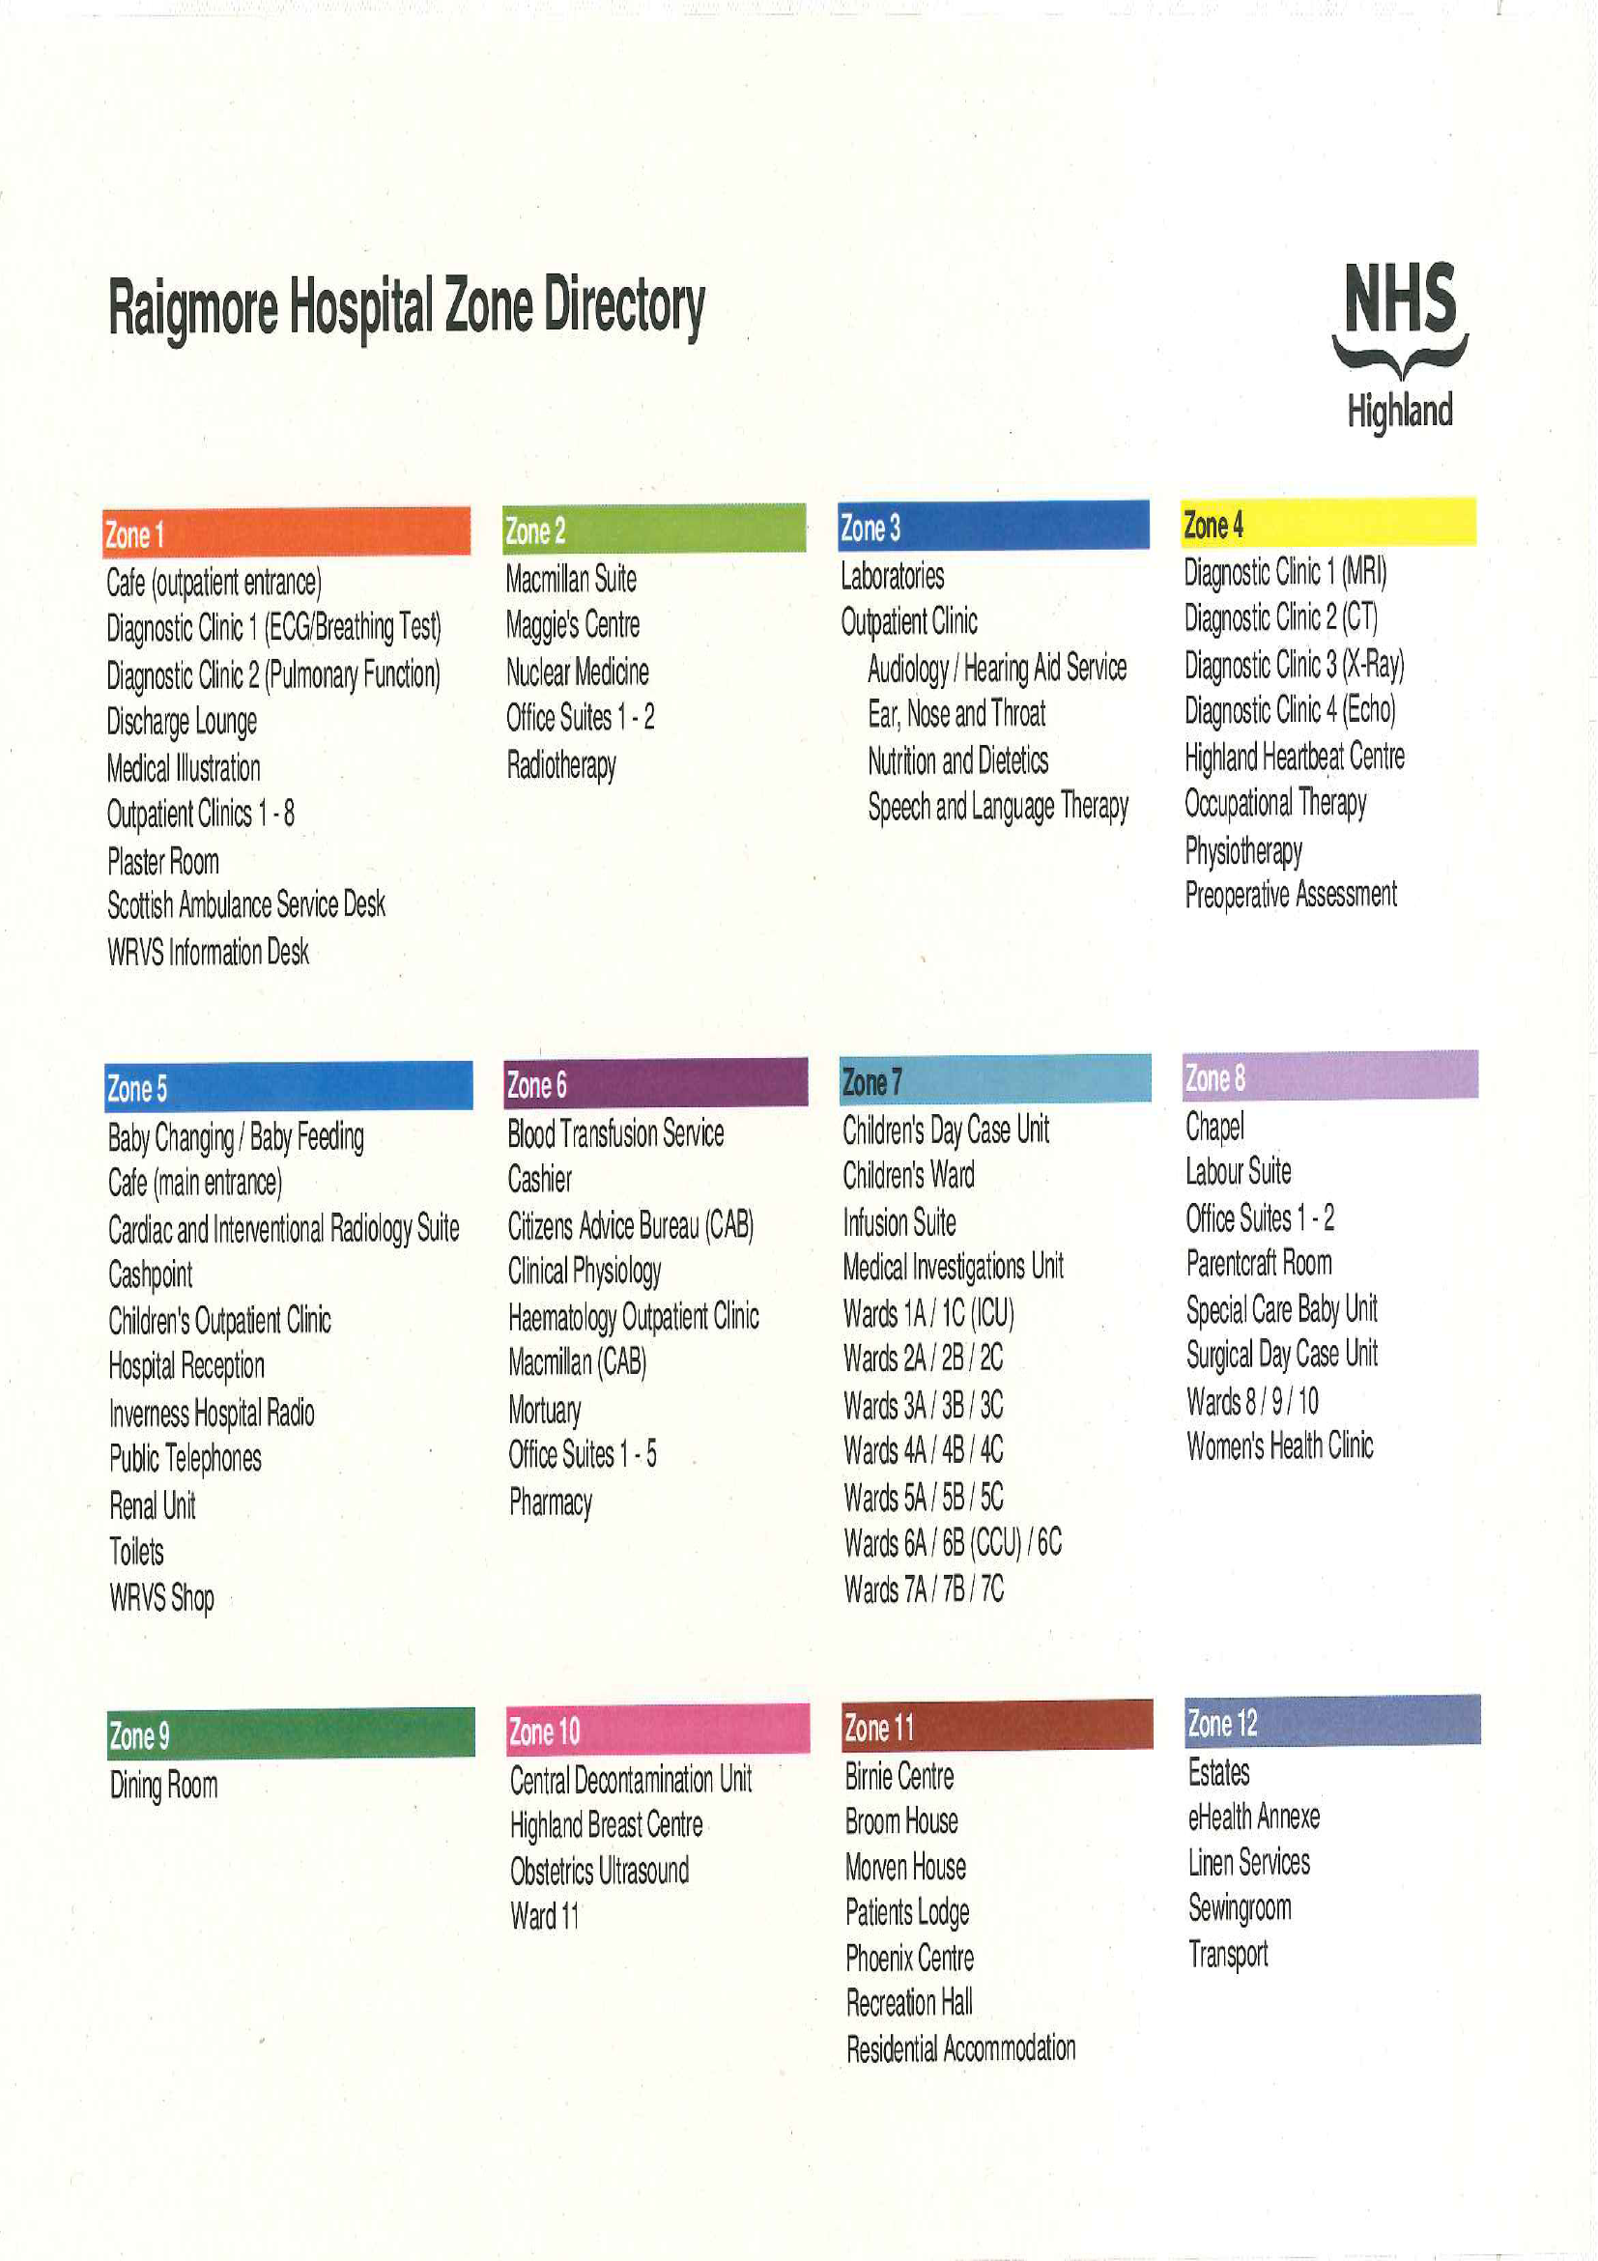

** Children’s Ward is now situated in Zone 10**

- Sports and Social
The Highland Health Sports & Social Club is run by a small Committee within Raigmore Hospital, for the benefit of members within the NHS Highland region. Our aim is to bring like minded people together for social and sporting activities, and to try and promote a greater community spirit within the Hospital. In addition to the Fitness Facility and licensed Function Room, we also organise excursions to concerts/sporting venues/shopping trips and other events
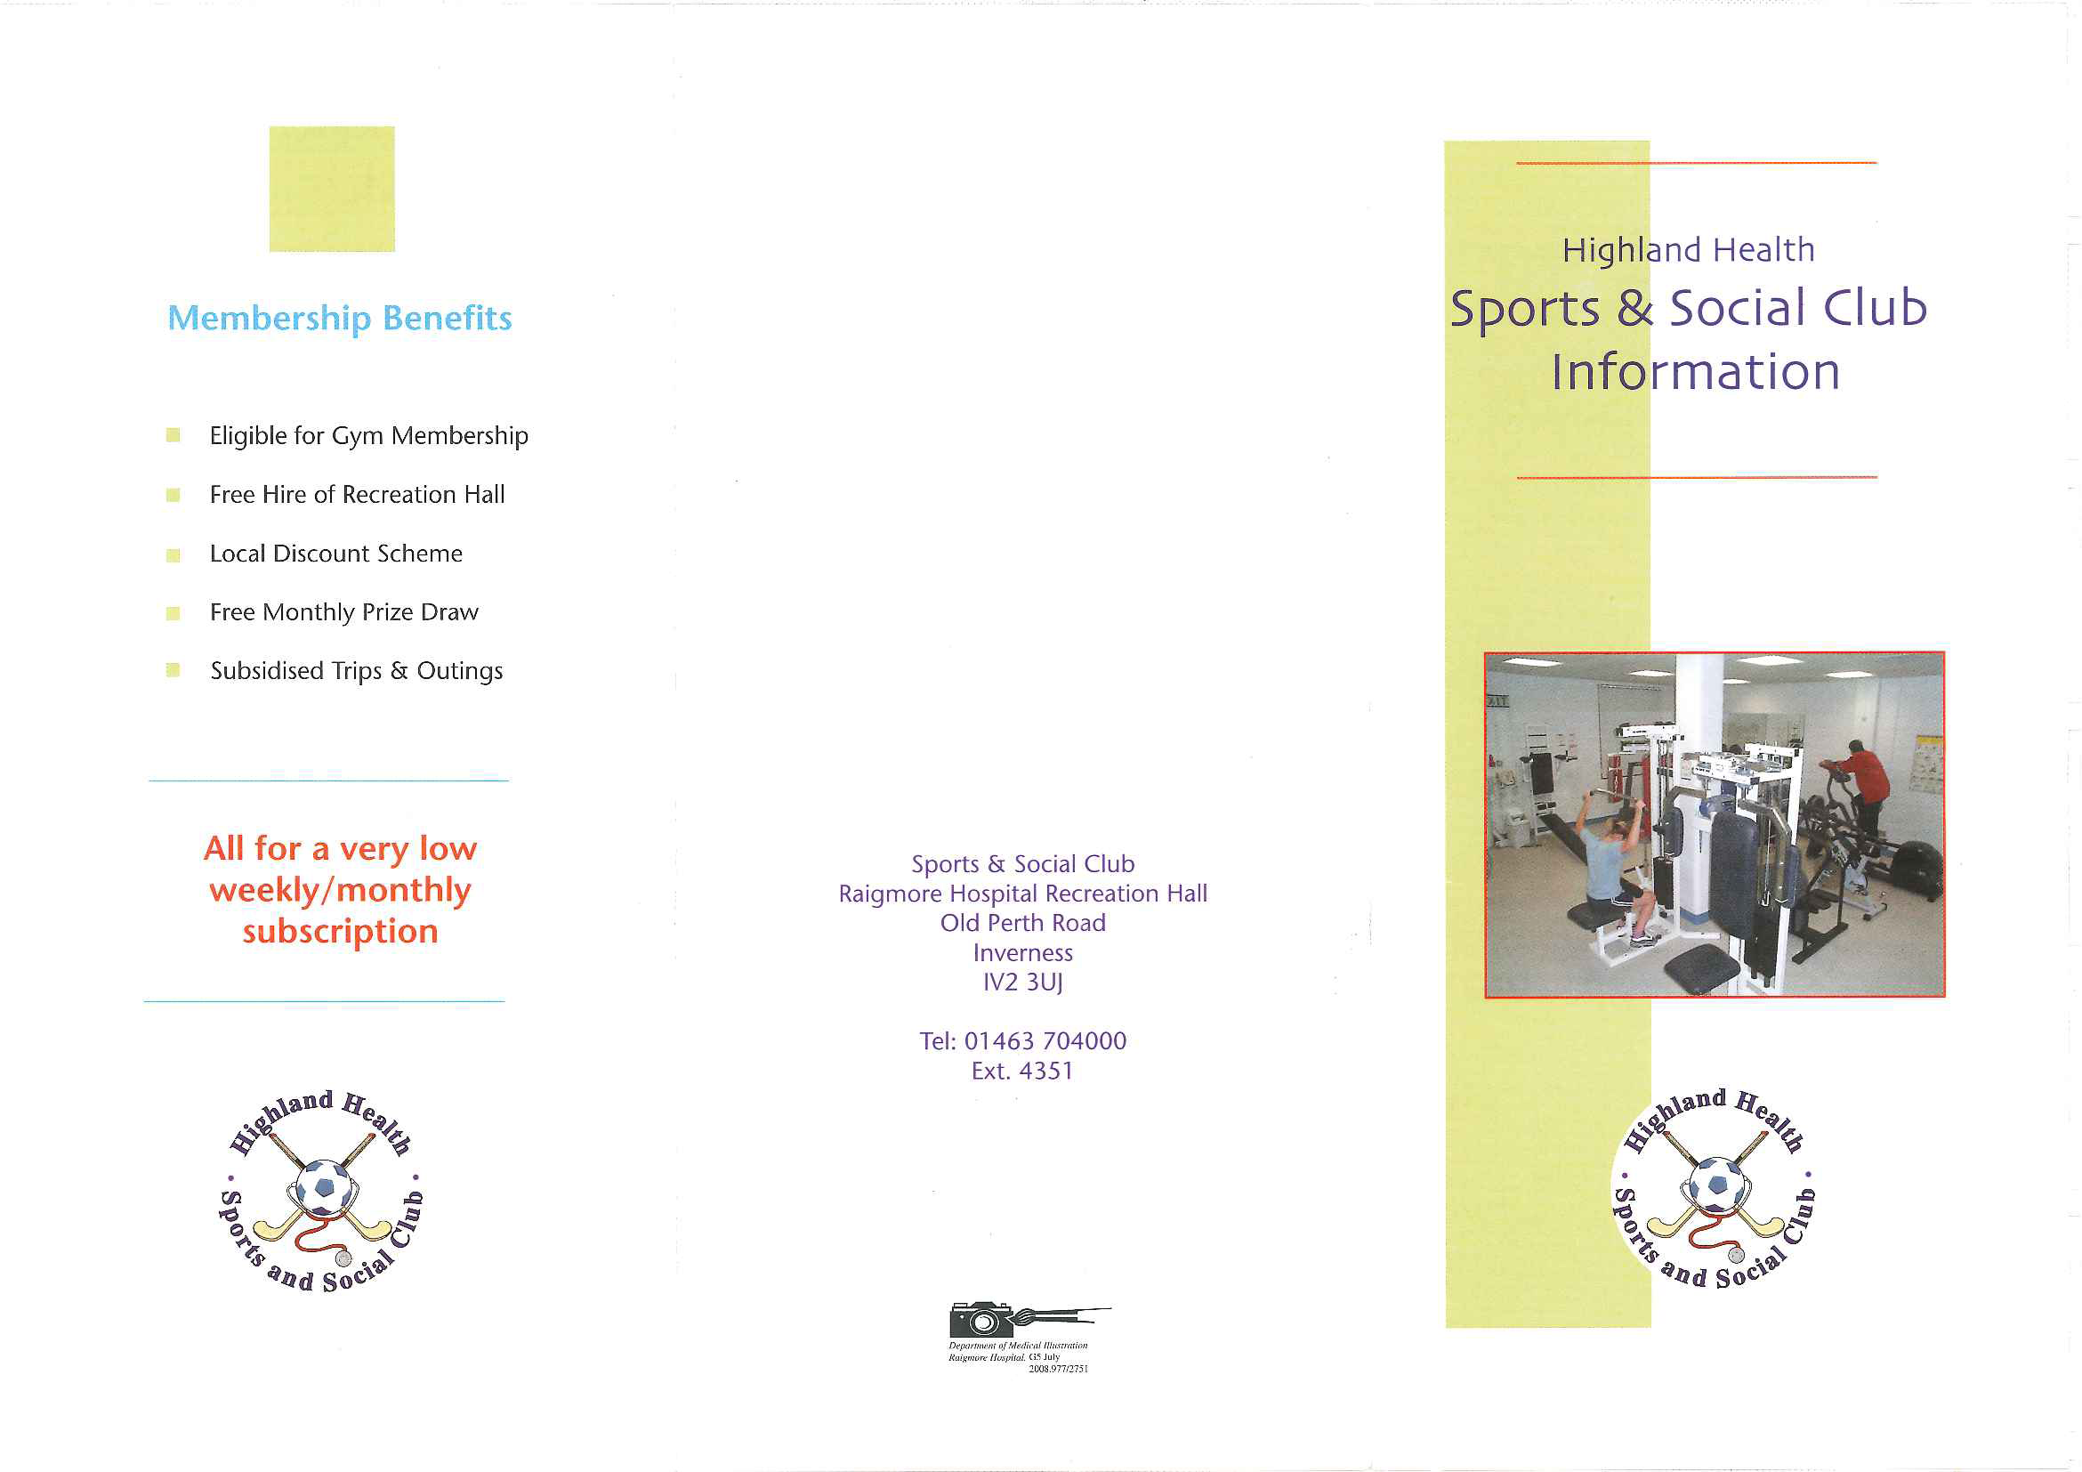
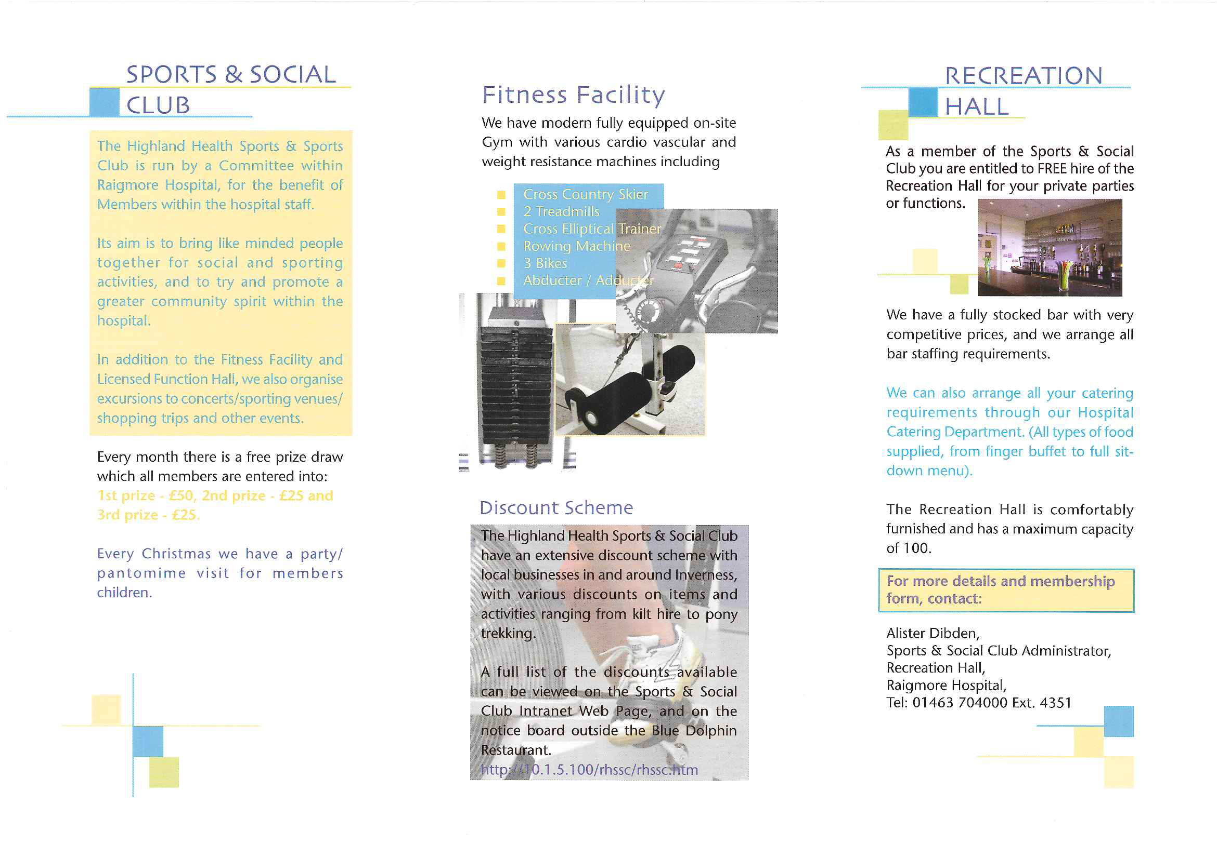

Hospital at Night

Hospital at Night Team - (also includes evenings and weekends)

The H@N team is a multidisciplinary team which includes 3-5 StR’s or MG equivalent from medicine, surgical and orthopaedics respectively, 2-3 FY level Doctors from medical, surgical & orthopaedics and two Advanced Nurse Practitioners (ANP). The team provides care to all adult inpatients excluding obstetrics, paediatrics, A&E, gynaecology & ITU within Raigmore Hospital between 2045hrs and 0915hrs every night. Monday to Friday evening’s 1715-2115hrs and Saturday and Sunday days 0845-2115hrs are also covered by the H@N team.

The H@N team aims to provide high quality, safe and effective clinical and emergency care across 13 medical and surgical wards within Raigmore Hospital. Current clinical specialities include; general surgery, vascular surgery, urological surgery, orthopaedic surgery, oral surgery, care of the elderly, stroke medicine, cardiology, renal medicine, endocrine, respiratory medicine, dermatology, ophthalmology, ear nose and throat, oncology and haematology plus all level 2 care areas - SHDU, MHDU & CCU.

Ward nursing staff will contact the ANP in the first instance for clinical advice unless there is a junior doctor allocated to that area The tables below show the out of hours cover for each ward.

SURGICAL & ENT | Mon-Fri 1700-2130hrs | Nights 2045-0915hrs | Sat & Sun 0845-2115hrs
Ortho wards | Ortho FY1, Blp 1094 | ANP (Surg), Blp 5200 | Ortho FY1, Blp 1094
ENT | 1/2 day late FY1 (Surg), Blp 6033 | ANP (Surg), Blp 5200 | FY1 (Surg) 0745-1745hrs Blp 6033, then ANP (Surg) Blp 5200
4C | 1/2 day late FY1 (Surg), Blp 6033 | ANP (Surg), Blp 5200 | FY1 (Surg) 0745-1745hrs Blp 6033, then ANP (Surg) Blp 5200
5C | 1/2 day late FY1 (Surg), Blp 6033 | ANP (Surg), Blp 5200 | ANP (Surg), Blp 5200
4A & SHDU | FY1 Rec (Surg), Blp 6009 | FY1 Rec (Surg), Blp 6009 | FY1 Rec (Surg), Blp 6009
9B | Gynae/breast team | ANP (Surg), Blp 5200/Gynae on call | ANP (Surg), Blp 5200/Gynae on call

MEDICAL | Mon-Fri 1700-2130hrs | Nights 2045-0915hrs | Sat & Sun 0845-2115hrs
2A & 2C | Dr JMG, Blp 2051 | ANP (Med), Blp 5300 | ANP (Surg), Blp 5200/Dr JMG, Blp 2051
5A | Dr JMG, Blp 2051 | ANP (Med), Blp 5300 | ANP (Med), Blp 5300/Dr JMG, Blp 2051
6C | Dr SMG, Blp 2050 | ANP (Med), Blp 5300 | ANP (Med), Blp 5300/Dr SMG, Blp 2050
7A & 7C | Dr MG, Blp 4001 | ANP (Med), Blp 5300 | ANP (Med), Blp 5300/Dr MG, Blp 4001
MSCU & CCU | Dr SMG, Blp 2050 | Dr SMG, Blp 2050 | Dr SMG, Blp 2050

A few points to note:-
- Ortho Registrar has protected sleep from 0100-0700hrs except for sick patients on the wards or complicated admissions. Straightforward emergency admissions during this time are clerked by the ANP(Surg).
- There is a Surgical Registrar on call every night & at weekends who should be available to be contacted by the ANP (Surg)/FY1 (wards) as appropriate for deteriorating patients on surgical wards, or the FY1 Rec for issues in SHDU or 4A.
- If the FY1 Rec for surgery is called to theatre overnight, he/she must inform the ANP (Surg) so that any work can be re-allocated.
- The ANPs are available for support with clinical skills (cannulation, catheterization etc.) in level 2 areas (CCU, MHDU, SHDU).
- Emergency ENT/opthalmology admissions will be clerked by the ANP at night and after 6pm Sat & Sun after discussion with the relevant registrar.
- Out of hours medical receiving calls will be directed to the bleep holder on for medicine (4000), Surgical calls to the receiving FY1 (6009), Orthopaedic calls to the Ortho MG on call (3000) and ENT calls to the ANP’s (5200)
- The cardiac arrest team comprises - SMG Dr on bleep 2050, JMG Dr on bleep 4001 and both ANPs on bleeps 5200 & 5300.
- In general, the ANPs cover by ward (including boarded) patients, rather than by specialty as is the case with doctors.
The OOH’s bleep policy should be referred to for completeness. This is in the process of being updated.

It cannot be emphasised strongly enough that the out of hours medical and nurse practitioner staff operate as a team. If the ANP who is contacted in the first instance is unable to attend for any reason, he/she will forward on the caller to the most appropriate member of the team. By the same token if any member of the team requires assistance/support he/she must be able to call for help from any of the rest of the team.

Advanced Nurse Practitioners

There is currently a team of nine ANP’s with two on duty every night between 2045-0915hrs. All have completed an advanced clinical assessment course and using advanced practice skills will undertake physical assessment and history taking of patients and provide immediate care and initiate treatment. They are non-medical prescribers and will prescribe according to their level of knowledge and expertise in conjunction with NHSH policy. They will refer patients to the MG Doctor as appropriate.
They form part of the cardiac arrest and medical emergency team (MET) and attend all clinical emergencies in the OOH’s period and also support emergency admissions. ANP’s are also the senior nurse for Raigmore hospital, deputising for the on call duty manager and nurse managers during the OOH’s period, taking responsibility for and dealing with site management issues, including staffing, bed management and resource allocation. They are also the first responders for fire and security alerts pending the arrival of wider fire and security teams.

The ANP on duty during weekday evenings has a NON-CLINICAL role, except for cardiac arrest, fire, security and MET.

Hospital at Night Handover

Effective handover is essential to safe and efficient patient care particularly OOH’s when there is limited staff and resources available. For the H@N to work it is essential that all staff expected to attend should do so. If, in the case of an emergency this is not possible, then the ANP should be informed on bleep 5200/5300 or telephone the 2B meeting room on ext.6410. ANPs or the senior middle grade on duty are responsible for co-ordinating the handover to ensure it runs smoothly.

- All H@N handovers take place in the 2B meeting room unless otherwise stated

- Evening handover takes place 1700-1730hrs Mon-Fri
- Night handover takes place 2045-2115hrs daily.
- Surgical, ENT & Orthopaedic morning hand back to day teams takes place at 0745-0800hrs

- Medical morning hand back takes place at 0845-0900hrs
- Sat & Sun morning handover takes place 0845-0900hrs. Orthopaedic and Surgical FY1s who start earlier should bleep the ANP (Surg) on Blp 5200 when they arrive to get their handback.
- Sat & Sun Surgical handover to ANP should be at 1730hrs and by arrangement between the individuals concerned. FY1 Surg (wards) should bleep the ANP (Surg) on Blp 5200 before he/she leaves the building at 1745hrs.

- Attendance at handovers is recorded, audited and fed back to clinical supervisors.

Please see attached documents for expected handover attendance lists, handover information sheets, handover SOPs and patient acuity guidelines,

Handover sheets are available on the intranet on the Hospital at Night page and the teams are encouraged to use them and pass to the following shift for action/ info.

Any management issues should be handed over to the appropriate nurse manager Monday to Friday or duty manager at weekends and public holidays. H@N NPs should also document any management issues in the division nurse manager folder, currently kept in H@N office 7th floor.

Please refer to documents sent with the Induction Booklet for more information on the Hospital at Night Handover Format and Handover Attendance.

Laboratory Systems

Laboratory Systems
1. Normal Hours Service

Biochemistry
Weekdays : 0900 - 1715
Weekend : Sat 0900 - 1230
Haematology
Weekdays : 0900 - 1730
Weekend : Sat 0900 - 1230
Microbiology
Weekdays : 0900 - 1730
Weekend : Sat 0900 - 1630
Cellular Pathology (Histopathology/Cytopathology/Mortuary)
Weekdays : 0830 - 1700

Contact

All new staff requiring IT training on the Results Reporting System should contact eHealth Helpdesk at Ext 4999.
Laboratory Enquiries
General |  | 4244
Biochemistry |  | 4210 / 11
Blood Transfusion |  | 4216
Haematology |  | 4258
Microbiology |  | 4206/7
Cellular Pathology | (Histopathology/Cytopathology/Mortuary) | 4266
Consultant Service Lead
Biochemistry | Dr M van Drimmelen | 8291
Haematology | Dr J Craig | 4256
Microbiology | Dr A Brown | 4206/7
Cellular Pathology | Dr G Stenhouse | 6553
Laboratory Services Manager | A Javed | 4088
Head Biomedical Scientists
Bacteriology | G Widdows | 5671
Biochemistry | B Morrison | 4117
Blood Transfusion | W Callan | 4216
Haematology | M Milner | 4158
Microbiology | Dr D Ashburn | 4206/7
Cellular Pathology | A Soden | 4265
Mortuary
Senior Anatomical Pathology Technician | D Scott | 4272 / Pager 5066
Infection Control
Nursing/General Advice | D Stark | 4206/7 5041
Medical Advice | Duty Microbiologist | 4206/7
Transfusion Practitioner |  | 4334

2. Out of Hours Service

The laboratories offer an emergency service for investigations that will influence the immediate management of patients.
Blood Sciences (Haematology and Biochemistry) – 24 hour shift
Contact BMS via Switchboard
(1715 - 0900 weekdays, 1300 Sat. - 0900 Mon)
Microbiology
Contact BMS via Switchboard
(1730 - 0900 weekdays, 1630 Sat - 0900 Mon)
Mortuary
Contact Switchboard for on-call member of staff
Histopathology/Cytopathology
There is no on-call service for Histopathology/Cytopathology.
Consultant Advice is always available in all specialties
Out of hours contact via switchboard.

Pharmacy Information
What do we do?
This service aims to provide accurate up to date information on all aspects of medicine use to anyone working within the health service, in either primary or secondary care.
Who is providing the service?
Enquiries are answered by a qualified pharmacist who has undergone at least the minimum training outlined by the UKMIG, a national body that lays down standards for Medicine Information services.
Where do we get the information we provide?
Information is gathered from a wide range of sources including: up to date reference texts, published peer reviewed journals and the pharmaceutical industry. We also have access to a network of specialist information sources on topics such as medicines in pregnancy, breast feeding, liver disease and complementary medicines. This will then be collated and interpreted by a pharmacist to give a suitable answer.
How can we be contacted?
We can be contacted in person at the pharmacy department, by telephone (extension 4288) or by e-mail at nhshighland.medicineinformation@nhs.net
During normal pharmacy hours if you have an urgent enquiry but are unable to contact us on the number given you can page number 1179.
How will the answer be provided?
Usually we speak to the enquirer in person and give an answer verbally. If the answer is complex or not urgent we may e-mail the answer or write a letter. All enquiries are logged within the pharmacy to allow us to retrieve the original information if we are asked a follow up question. As part of our quality assurance we may write out to enquirers with a questionnaire to find out if the service provided was satisfactory. We would welcome any other feedback too.

Please refer to the Statutory and Mandatory Prospectus

