

**Contact Details**

ASPC, 40 Chapel Street, Aberdeen AB10 1SP, 01224 632949, www.aspc.co.uk

Aberdeen University, King's College, Aberdeen, AB24 3FX, 01224 272000

Blackwood Homes, 16 Raeden Court  
Midstocket Road, Aberdeen, AB15 5PF, 01224 326331,

info@blackwoodgroup.org.uk

Citylets, www.citylets.co.uk, info@citylets.co.uk

Grampian Housing Association, Huntly House, 74 Huntly Street, Aberdeen, AB10 1TD, 01224 202900

Hanover (Scotland) Housing Association,

12 Institution Road, Elgin, IV30 1QX,

01343 548585, northinfo@hanover.scot

Homehunt NES, www.homehunt.info

Langstane Housing Association, 680 King Street, Aberdeen, AB24 1SL, 01224 423000, info@langstane-ha.co.uk

LAR Housing Trust – CITYLETS, 15 Pitreavie Court, Pitreavie Business Park, Dunfermline, KY11 8UU, 01383 745650

Osprey Housing, 22 Abercrombie Court, Arnhall Business Park, Westhill, Aberdeenshire, AB32 6FE, 01224 548000, enquiries@ospreyhousing.org.uk

Smithfield Court, via Aberdeen City Council, 01224 788565

Please note NHS Grampian does not endorse these providers and this leaflet should not be considered a recommendation. Individuals are responsible for arranging their own accommodation. All information is correct at the time of going to press.

For further information please contact the relevant council housing advice service:

Aberdeen Tel: 03000 200 292

Aberdeenshire Tel: 01346 514866

Moray Tel: 0300 123 4566.

Connect with NHS Grampian

Website: www.nhsgrampian.org

Facebook: facebook.com/NHS.Grampian.Scotland

Twitter: @NHSGrampian

Published: June 2017

Review Date: Dec 2017

## NHS Grampian

## NHS Grampian

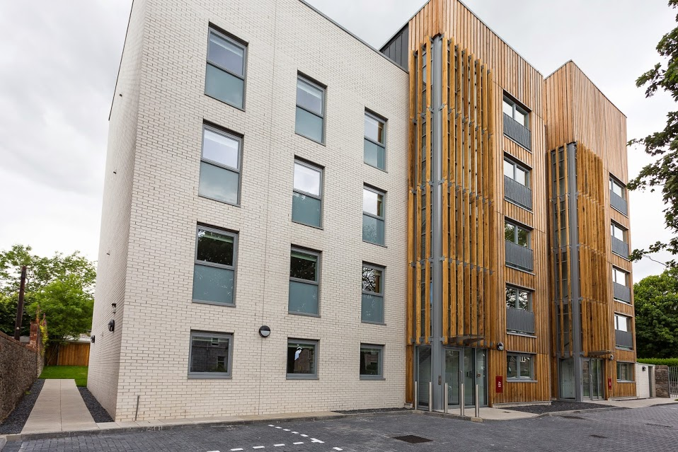

**Residential Accommodation**

**Information**

NHS Grampian - Caring, Listening, Improving

**CItylets**

Citylets advertise a wide range of accommodation to rent and buy in Aberdeen City and Shire. Properties range from studio flats to family homes, with prices starting from £325pcm for rent in Aberdeen city.

**Grampian Housing (Kirkgate Development)**

Properties offered range from 2 bedroom apartments to 3 bedroom houses across Aberdeen city and Aberdeenshire. These properties range from £610pcm to £710pcm.

**Hanover (Scotland) Housing Association**

A small number of developments, providing housing for families, often designed around small cul-de-sacs or courtyards to provide a safer environment for children and pets, are available.

**Homehunt NES**

Sanctuary, Grampian Housing, Castlehill and certain Aberdeen City Council House allocation is through Homehunt (choice based letting). Instead of keeping a waiting list, properties are advertised with a pcm rental price and prospective tenants can register an interest.

**Langstane Housing Association**

Provide affordable rented accommodation to single people, couples and families. They operate a waiting list system and those in housing need would have to apply and be assessed for housing. Stockethill Homes is a subsidiary of Langstane Housing Association and provide mid-market rent accommodation. Properties range from 1 to 2 bedrooms.

**LAR Housing Trust –Citylets**

Unfurnished accommodation is available at Shaw Road, Aberdeen. A one bedroom Apartment will cost in the region of £500pcm.

**Osprey Housing**

Osprey Housing and Osprey Housing Moray, have approximately 1500 properties across Aberdeen City, Aberdeenshire and Moray. These range from 1 bedroom flats to 5 bedroom family accommodation.

**Smithfield Court**

Furnished 1 and 2 bedroom flats available ranging in price from £80pw for a 1 Bedroom to £90pw for a 2 bedded flat.

**ASPC**

There is a wide range of accommodation available to rent and to buy. Properties range from studio flats to family homes, with prices starting from £350pcm for rental properties in Aberdeen city.

**Aberdeen University- campus**

Accommodation is available at Kings Hall (en-suite rooms) and Elphinstone Road on a room only basis, with prices ranging from £110pw to £140pw.

**Aberdeen University – Hillhead**

Accommodation is available at North Court, Keith House and Adam Smith on a room only basis. Prices range from £110pw to £150pw, with direct bus services to the Foresterhill Campus at Aberdeen Royal Infirmary.

**Blackwood Homes**

Provide houses at affordable rents or for shared ownership for disabled and non-disabled people and their families. Properties range from 1 bedroom flats to 5 bedroom family homes.

### Accommodation