E-Payroll “Self Service” Guidance Document

E-Payroll Self Service
Self Service is a function within the NHS Scotland e-Payroll system where you can check information about yourself that is held in the e-Payroll system. You can check your salary and pay history for the previous year plus other data held.

Electronic Payslips (e-Payslips)
As part of Self Service you will be able to view, print and/or save an electronic copy of your payslip. Once you receive your security envelope to access this facility, log in to your Self Service at the link below using the username and password provided, you will need to change your password before proceeding.

https://workforce.mhs.scot.nhs.uk/eYou/Authentication/Login.aspx

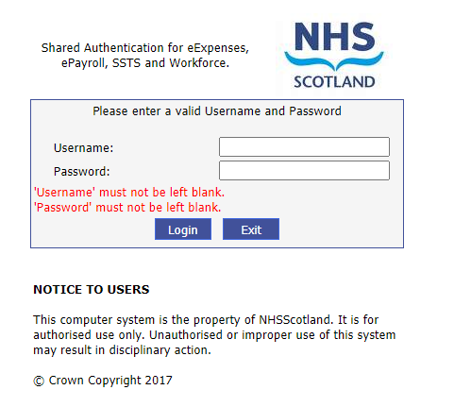

Using the e-Payroll System
Below is a view of the tabs currently holding information regarding your employment with NES (please note that this is not a real record nor does it relate to a real person).

You will be able to view this on the left side of your screen once you have logged in.
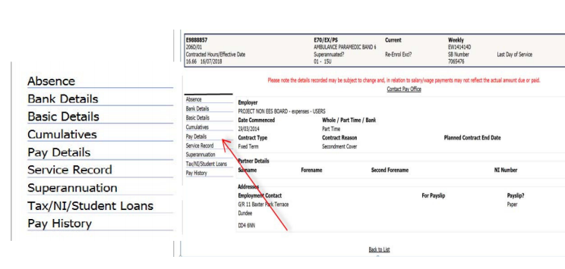

• Absence – This tab allows you to view the pay related absence information recorded by your manager onto SSTS that has been sent to e-Payroll. Currently details are held for the last 3 complete years plus the current year.

• Bank Details – This tab allows you to view the bank details currently held by the Payroll Department that will be used to make any payments to you. These should be checked if you are a new employee or you have recently changed your bank account to ensure that the changes have been notified and applied correctly.

• Basic Details – This tab allows you to view the details of your address currently held in e-Payroll, this will be the same for all employments held. The bands running across the top of the screen show personal information such as your Date of Birth, National Insurance number, Home Address, Payroll number and some employment details such as your grade. You will also be able to view your contract type e.g. fixed-term or permanent, along with your date of commencement and whether you are whole time or part time.

• Cumulative – This tab allows you to view your earnings and deductions details for the last complete year and current financial year to date for your:
o Hours worked
o National Insurance
o Superannuation
o Taxable Pay/Tax paid/Student loan Repayments & Current tax coding
o Other (Any Statutory payment made to you such as SSP/SMP) Charitable donations, loan balances and overpayment repayments made.

• Pay Details - This tab allows you to view your current pay information e.g. o Details of your Annual salary (Whole time equivalent value shown) o Incremental date o Basic/Enhanced and Overtime base rates o Salary Protection Details o Allowances & Deductions that will be applied each pay period o Loan Details/Balances to date.

• Service record – This tab allows you to view the details of current and previous NHS employments as well as any employments that would affect your employment within the NHS.

• Superannuation Details – This tab allows you to view your superannuation/pension for your current employment. o Date you joined the superannuation scheme (on the current post) o Superannuation Percentage o Details of the Pension scheme that you are in o SB/Contract number o Date of leaving the scheme (If applicable) o Additional Superannuation scheme contribution details (If applicable) Page 3 of 6 o Please note that this will not show your full superannuable service, for this information you would still need to contact the Scottish Public Pensions Agency (SPPA)

• Tax/NI/Student Loans - This tab allows you to view your details for Income Tax, NI and Student Loans e.g. o Details of your current tax coding o Date your student Loan started/ended & plan type o Total amount you have paid in student loan contributions this financial year o Details of any changes made to your tax code this financial year.

• Pay History (and e-Payslips) - If you select this tab, it will bring up the window shown below. This tab will default to showing you the latest pay period. You can change the pay period by making a different selection within the drop down menu.
Please note that details held on the latest payslip may be subject to change.
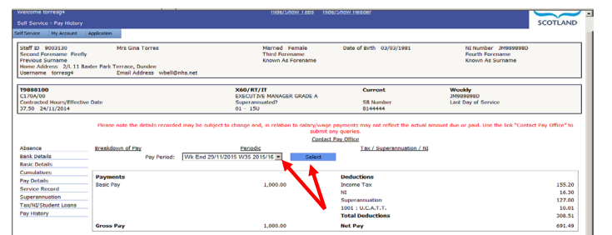

Once you have transferred to receiving e-Payslips you will then see the prompt as shown at the bottom of the window to “View/Print/Save Payslip”. Clicking this button allows you to view, print or save your actual e-Payslip.
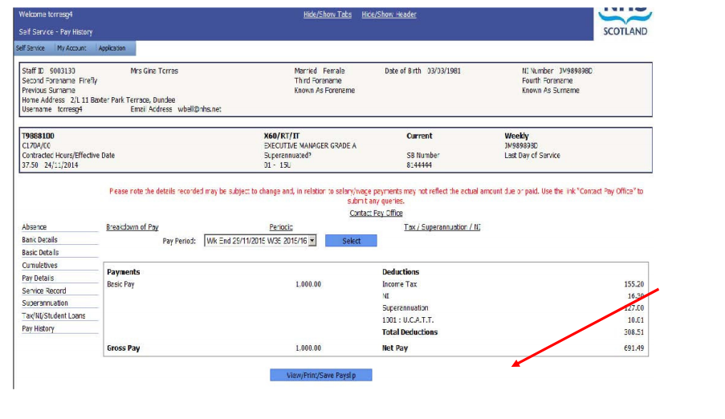

You can also contact the payroll office directly by clicking the “Contact Pay Office” link shown above which will direct you to a message window.

