Should you have issues with logging into our service desk please use the information below to help.

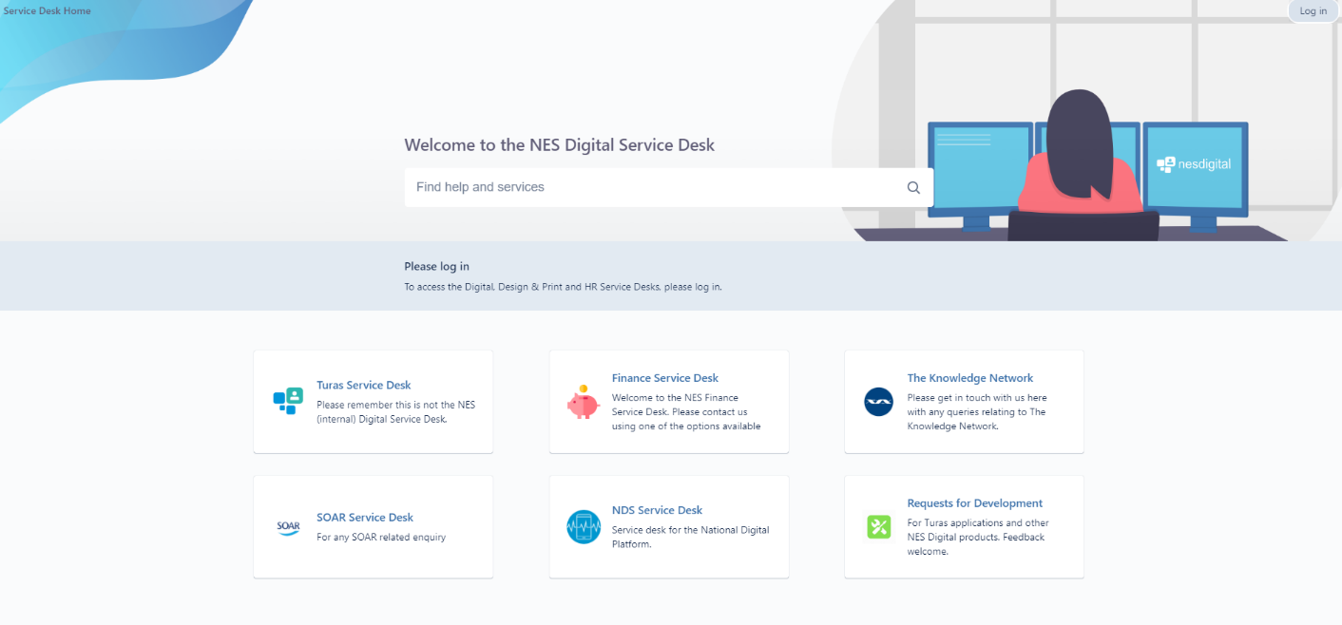
When you first open our service desk this the first screen you will see.

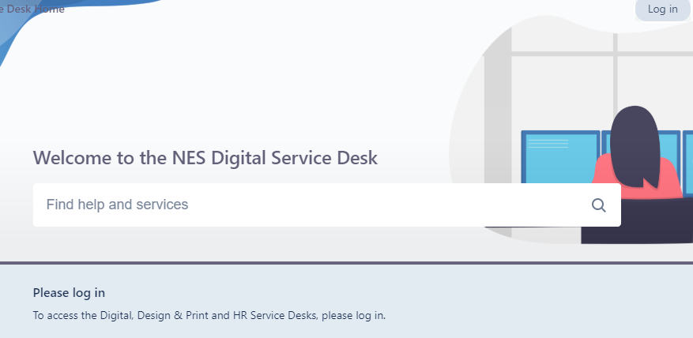
At the top right of the screen there is a ‘Log in’ button, please select this.

You will then see a log in box which has a line “Need An Account?” Sign Up (ie click on sign up)

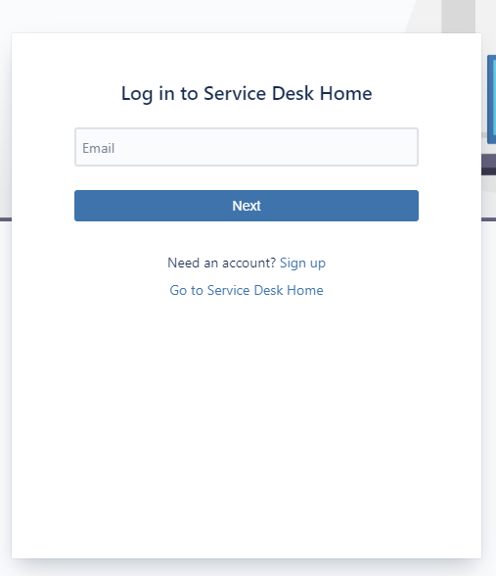

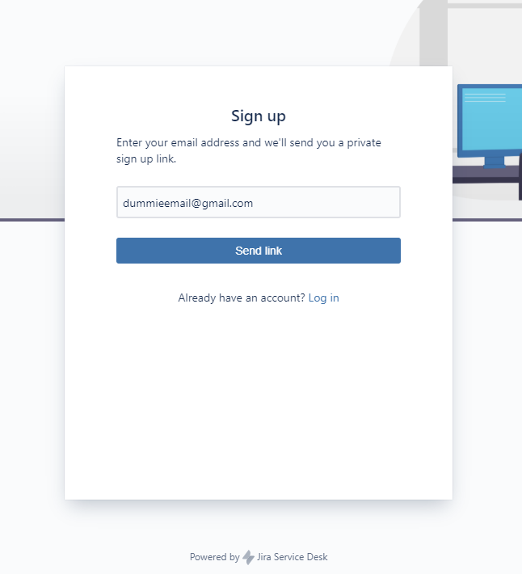
Enter your email address and a link will be sent to the email. Then use the link to log in for the first time and get access to Jira.

