NHS EDUCATION FOR SCOTLAND

DOCTORS IN TRAINING SHARED SERVICES LEAD EMPLOYER MODEL

STANDARD OPERATING PROCEDURE

October 2019

Content |  | Page
- Introduction |  | 3
- Aims |  | 3
- Roles & Responsibilities |  | 4
- System |  | 19
- Service Quality Assurance |  | 19
Appendix A | Policy Schedule – Policies, Procedures and Guidelines for Doctors in Training | 20
Appendix B | Employee Relations Process Maps

- Introduction
The purpose of the Doctors and Dentists (DDiTs) in Training Shared Services Lead Employer Model is to deliver an improved recruitment and employment experience for doctors and dentists in training, and enhanced effectiveness and efficiencies in practice - one employer for the duration of a training programme.

All GP, Public Health and Occupational Medicine Specialty Trainees will be employed by NHS Education for Scotland (NES) for the duration of their training programme. Whilst NES will be the Employing Board for these trainees, they will continue to rotate around Placement Boards and General Practice attachments as part of their training programme.

In accordance with the Employment Responsibilities Agreement, this document is intended to set out the roles and responsibilities of the Employer Board and Placement Board in undertaking the day-to-day management and activities in supporting the Doctor in Trainings employment journey throughout the training programme. The Employment Responsibilities Agreement at section 4.5 describes the following arrangements:

The Employing Board and Placement Board will agree Standard Operating Procedures for the employment of Doctors in Training in respect of the Employment Responsibilities set out in Appendices B and C, which Standard Operating Procedures may be amended by the Employing and Placement Boards, from time to time. The Standard Operating Procedures may include agreement between the Employment and Placement Boards that the Placement Board will carry out certain of the Employment Responsibilities incumbent upon the Employing Board, on its behalf.

This document seeks to describe the extent of the activities that the placement Board will carry out on behalf of NES. This document will be reviewed at 3, 6, 9 and 12 months.

In this document NHS Education for Scotland (NES) may be both the employing and placement board if Doctors in Training are in general practice.

- Aims
- Provide Doctors in Training with optimum continuity of employment and positive employment experience.
- Doctors in Training will have one Employer per training programme.
- Doctors in Training will have on onboarding pre-employment check per training programme to include reference, PVG, OHS and Visa checks where appropriate.
- Doctors in Training will receive one employment contract per programme.
- In the absence of the National Policies & Procedures for Doctors in Training, the Lead Employer policies will apply unless otherwise agreed.
- NHS Education for Scotland (NES) as the Employer Board will pay all GP, Public Health and Occupational Medicine Specialty Trainees and there will be supporting financial cross charging and monthly financial report arrangements in place.
- All other NHS Scotland Boards and General Practices will become Placement Boards and will work on behalf of NHS Education for Scotland (NES) in order to manage the Doctors in Training.
- Define the extent of delegated employment related activities that placement Boards will deliver on behalf of employing Boards and the agreed standard to which these will be delivered.

- Definitions
Employing Board: means the Party which is the employer in respect of a Doctor in Training who is the subject of the relevant Placement Agreement;
Placement Board: means the Party providing a training placement to the Doctor in Training under the relevant Placement Agreement;

4. Roles and Responsibilities
This section specifies the agreed Employing Board and Placement Board responsibilities for activities pertaining to Medical Staffing/Employee Relations, Finance, Payroll and Occupational Health functions. NHS Education for Scotland also has a Training programme management role for trainees that is described in the Employment Responsibilities Agreement and is detailed below.

POSTS/ RECRUITMENT

Action | PB/  EB | Delegated responsibility to Placement Board to deliver on behalf of Employing Board | Deanery Role | Standard | Dependent Upon
Offer of training programme and allocation. | N/A |  | Following the release of National offers, Training Programme Management team provide the training programme offer and allocation. Deanery update on TPM. | Agreed UK systems and Turas processes  Agreed onboarding processes | Agreed UK systems equivalent acceptance processes.  National offers.

PRE-EMPLOYMENT CHECKS

Action | PB/  EB | Delegated responsibility to Placement Board to deliver on behalf of Employing Board | Deanery Role | Standard | Dependent Upon
Issue Conditional Offer Letter | PB | The Placement Board will send conditional offer letters via Turas People to successful candidates within agreed timescales. |  | Code of Practice.  CEL 10 (2014) | Offer of a training programme from NES Deanery and allocation to a programme and Employing Board.
Pre- Employment checking | PB  PB  PB  PB  PB | The Placement Board will ensure that all required pre-employment checks are carried out via Turas People including references, immigration status/right to work checks; criminal records background checks; occupational health checks; independent safeguarding authority & protection of vulnerable group checks; identity checks; qualifications; Foundation Competency; ALS; GMC (where applicable) and also ensure that appropriate medical clearance is obtained in accordance with NHS Code of Practice and Fitness to Practise. SEE ALSO STAFF ENGAGEMENT FORM SECTION.  The Placement Board will ensure all Doctors in Training are eligible to commence in post on the given start date.  The Placement Board is responsible for putting in place a risk assessment if pre-employment checks aren’t complete to allow Doctors in Training to start in post.  The Placement Board will notify NES Deanery of any non-cleared Doctors in Training and detail the reason for delayed clearance.  The Placement Board will upload any additional recruitment information onto Turas People. | Involvement in Fitness to Practise decisions. | In line with PIN Guideline: Safer Pre and Post Employment Policy requirements.  Medical recruitment handbook for recruiting offices  UKVI guidelines  Minimum 2 references (supervisor reports) one being the most recent employer or educational institute  Declaration form completion  Sight check and verification of ID prior to or at commencement of first placement | Dependent upon the Trainee returning documentation and required information.  Also subject to Disclosure Scotland and UKBA undertaking their obligations in a timely manner.  Referees, OH provider, GMC updating register in a timely manner with accurate information.  Trainee completing and returning FTP Declaration form.  Placement board having arrangement in place re checking of ID/Passport
Tier 2 | PB | The Placement Board will notify NES as the Tier 2 Sponsor of any employment matters which may affect a Doctor in Trainings Visa immediately eg. Absence, LTFT applications, maternity leave.
Confirm Placement Detail | PB | The Placement Board will advise Doctors in Training of their placement by issuing a “Placement Detail Letter” via Turas People including banding supplement where applicable (hospital placements only). |  | Code of Practice.  Standard Placement Detail letter | Offer of a training programme from NES Deanery and allocation to a programme and Employing Board.  Placement information to be available on Turas People in a timely manner.
Staff Engagement Form | PB  PB  PB/ EB  PB | The Placement Board will complete and authorise the Staff Engagement Form (via Turas People) details in order for the data extract to be completed for payroll processing and for the trainee to be added to NES payroll and paid monthly. This includes ensuring any protected salaries are processed correctly for Doctors in Training. If any trainees fail to start, the Placement Board will immediately notify Employing Board payroll in order for payment to be stopped.  The Placement Board is responsible for checking criminal conviction and fitness to practice declarations in section 11 of the staff engagement form on Turas People as part of the pre-employment checks. Any declarations should be reported to NES Deanery. The placement board should complete any risk assessments as defined in the PIN guideline.  Where discretion needs to be applied for more serious convictions, placement board will escalate to employing board.  Where NES is the Placement Board for GPSTs in a practice placement, NES will confirm the salary setting in the data extract for payroll. NES will confirm with all training practices that the trainees have commenced their placement and can be paid. | Following a notification of a fitness to practise issue, NES Deanery will investigate further.  Responsible for reviewing and approving any requests from Doctors in Training for overseas/locum service to be applied in respect of incremental credit. | As per Terms and Conditions Circulars  In line with PIN Guideline: Safer Pre and Post Employment Policy requirements. | Dependent upon the Trainee returning documentation and subject to placement Board practice in SEF completion, pending agreement of a consistent approach.
Targeted Enhancement Recruitment Scheme (TERS) Payment for GPStRs | PB  EB | For GPStRs who are eligible for a TERS payment, the Placement Board will arrange for the TERS agreement to be signed by the Doctor in Training before sending to the NES Deanery for approval. The Placement Board will then process the payment via a staff engagement form/notification of change form.  The Employing Board will be responsible for ensuring payment of the bursary. | NES Deanery should send the names of Doctors in Training eligible for a TERS payment to Placement Boards together with the updated TERS agreement.  Once the TERS agreement has been signed by the Doctor in Training and returned, the Deanery will arrange for the agreements to be signed by the Director of Finance. |  | Timely information to Placement Boards from NES Deanery and the Doctor in Training signing and returning the agreement.
Verification of Identity | PB  PB | The Placement Board will ensure all Doctors in Training identification is verified on the first day of placement in line with local procedures in accordance with the PIN guidelines.  Where NES is the Placement Board for GPSTs in practice placement, NES will liaise with practices to ensure identification is verified on the first day. |  | In line with PIN Guideline: Safer Pre and Post Employment Policy requirements.

EMPLOYMENT

Action | PB/  EB | Delegated responsibility to Placement Board to deliver on behalf of Employing Board | Deanery Role | Standard | Dependent Upon
New Starts and Leavers | PB | Ensure that new starters outwith the National recruitment process and leavers information is communicated to the Employing Board and the Deanery. |  | Agreed information flow. Turas reporting. | Turas Functionality.
Contract/Salary/Banding | PB  PB | The Placement Board will ensure Doctor in Training is notified of banding supplement for posts 6 weeks prior to commencement of placements via Turas People (applicable to hospital placements only).  The Placement Board will ensure contracts of employment are issued to new starters in a timely manner (and no later than 8 weeks after starting in post) via Turas People and preview these prior to issue to ensure accuracy. | Providing confirmation of allocation to enable placement boards to give 6 weeks’ notice of banding supplement.  Deanery need to ensure that detail in relation to placements is accurate on Turas TPM to feed through to contracts. | Code of Practice  Circulars.  Nationally agreed terms and conditions.  Standard contract documentation  Turas People. | Doctor in Training providing sufficient evidence from previous employment to be accurately placed on the scales.  Dependent on Placement Board providing accurate information.
Pay Band Appeals (hospital placements) | PB | The Placement Board is responsible for arranging and hearing Banding Appeals (applicable to hospital placements only). |  | Within 2 weeks of the change being signed off through due process.  Banding Appeals Protocol. | Receipt of timely and accurate information regarding Doctors in Training rotating to the Placement Board.
Amendments to Contract | PB | The Placement Board will ensure that any amendments to contract due to changes to training programme notified by NES Deanery are actioned through payroll and amendment to contract documentation is activated via Turas People with all system and employee files being updated. | TPM to update Turas with any changes that will impact on T&Cs eg. change in hours, change of end date.  TPM to keep Turas information accurate and current to facilitate any amendments to contract. | Payroll deadlines. | NES Deanery providing adequate notice of any changes to the training programme that may impact on contractual terms or on payroll e.g. OOP.  Turas People alerting Placement Boards of relevant changes.
Financial References/  Confirmation of Employment | PB | The Placement Board will provide bank and building societies with financial references following approval from the Doctor in Training via Turas People. The Placement Board is responsible for all such queries. |  | Templates.  To agree Response time. | Doctors in Training providing consent.
Enquiries | PB | The Placement Board will respond to enquiries from Doctors in Training about their Terms and Conditions of Service and contracts in accordance with the relevant policies.  Where a query arises as a result of an over or under payment, responsibility will rest with the placement board. | TPM to provide accurate and timely training information that has an impact on employment eg. Change to end dates, LTFT | Agreed enquiries/  escalation process  National policies.  Employing Board Policies | Mailbox/contact numbers available in accordance with local boards standards.  Full list of Employing and Placement Board contacts available to Doctors in Training on Turas Hub.
Employee Record | PB  PB | The Placement Board is responsible for maintaining Doctors in Training personnel file and employee record on Turas People throughout their employment as details in subsequent sections.  Placement Board will maintain Doctors in Training personnel and payroll information on Turas People as appropriate to ensure that relevant information, records and documentation held for employment purposes are accurately maintained and validated. |  | KPIs  Equality Outcomes/ Reporting of Employing Board. | Turas People generating an electronic personnel file/employee record. Reports will be generated for the purposes of employment law and the equality duties. An accurate minimum dataset (for Equality and Diversity purposes) will be maintained and will be able to be reported by Placement Board/ Employing Board.
Fitness to Practise | PB  PB  PB | The Placement Board will use all reasonable endeavours to ensure that NES is able to discharge its responsibilities under the Responsible Officer Regulations. The placement board requires to notify the Responsible Officer or delegates (or nominates) of any concerns which might be relevant to the fitness to practise of a Doctor in Training. See appendix D of Employment Responsibilities Agreement.  Placement Board HR staff to monitor and appropriately action any ongoing issues advised by Deanery staff. Placement Board HR to continue to liaise with Deanery, including Performance Support Unit, as appropriate. The placement board will provide HR representation at the PSU case work meetings.  Where a fitness to practise issue may lead to GMC referral, the Employing Board also delegates to the Placement Board, the requirement to have a GMC registered and licensed doctor who, in conjunction with the Placement Board HR, and as described in NES Policy can take responsibility for any investigation or disciplinary procedures involving Doctors in Training. The Placement Board will liaise with the appropriate NES Postgraduate Dean or Medical Director regarding any fitness to practise issues that may need consideration for referral to the GMC and/ or other relevant regulatory Bodies. Placement Boards will be aware that investigatory processes can often take several weeks to conclude, and to ensure that time is not lost unnecessarily, consideration should be given to GMC referrals at the earliest stage where required.  Investigations will be initiated by the Placement Board and any involvement from NES at this stage should only be to provide information from an educational perspective should it be required.  Further detail on the disciplinary processes and delegated responsibilities are detailed below. | Deanery staff to monitor Fitness to Practise issues on an ongoing basis and to share any concern with the Responsible Officer/delegates and Placement Board HR. | GMC Good Medical Practice | Training Programme Management team to be able to provide detailed, accurate, timely information with regard to Doctors in Training employed by NES.
Alerts | PB | The Placement Board will follow up any alerts from Turas People to ensure all Doctors in Training comply with and meet their requirements to maintain GMC registration and satisfy PVG and Right to Work requirements. The Placement Board will notify the NES Deanery of any issues. | TPM/Deanery staff to advise NES HR of any fitness to practise concerns. | Monitoring systems in place with GMC/ GDC and PVG.  Right to work monitoring and review mechanisms in place. | Turas People will generate alerts when there is a change to GMC status.  Notification from NES of changes to PVG status.  Certificate of Sponsorship from NES.
Working Hours | PB | The Placement Board will ensure that the requirements of New Deal and working time directive are satisfied in respect of each Doctor in Training on placement. |  | National TCS hours monitoring requirements | Placement Boards having robust monitoring processes in place.
Annual Leave | PB | Ensure that annual leave is taken in accordance with policy and local procedures.
Policies & Procedures | PB  EB/  PB | In the absence of National Policies, the Placement Board will follow NES Policies as detailed in Appendix A and as per the contract of employment.  Whilst the default policy will always be that of the employing board, there may be certain circumstances where the policy of the placement board will be applied. This will only occur in complex situations where cases involve multiple employees who are employed by different employers. In cases such as this, agreement should be sought from all parties to use one policy as opposed to multiple ones. Usually it will be the policy of the person who is bringing the grievance or who is the subject of potential disciplinary action, for example, which would be followed. In these circumstances, where a placement board policy is agreed, that policy will become the applicable policy in terms of the trainee contract. Where agreement cannot be reached, the employing Board policy will be applied.  The Employing Board and Placement Board will be involved in drafting revisions to the National Guidance/Policy through the SMT HR Sub Group. Changes to other guidance/policy of the Employing Board will meet PIN Guideline requirements. Any changes to National guidance/policy must be remitted through SMT Policy Sub Group with ratification through the Core Group. Final sign off through SJDC. |  | PIN Guidelines/ Nationally agreed Policies.  Legislation.  Turas Hub  Staff Governance Standard: Well informed.  Contract of employment, terms and conditions. | Employing Board policies and procedures to be applied in the absence of National Policies and Procedures.  Information being updated regularly. Clear signposting.  Clear communication to placement Boards, doctors in training and other stakeholders of any changes to NES Policy.  NES HR will ensure the Hub is kept up to date and accurate.
Absence Management | PB  PB  PB  PB  PB  PB  PB  PB  PB  PB  PB  PB  EB | The Placement Board will ensure timely, accurate monitoring, recording and management of all sickness absence for Doctors in Training in accordance with the Employing Board policy and will report absence on SSTS, and monitor the absence of trainees on placement in the Placement Board using Turas People.  The Placement Board will continue to action rotation details for Doctors in Training whilst they are on sick leave.  The Placement Board will ensure sickness absence information, first day of absence, return to work date, is shared with payroll through SSTS.  The Placement Board will ensure that NES Deanery, including the Performance Support Unit, is alerted of any long-term sickness absence cases.  The Placement Board will attend regional performance support meetings to discuss trainees employed by NES with absence related performance support issues. The PB HR will advise on application of NES policy in managing the employment impact of such issues.  The Placement Board will engage OH as required in sickness absence management.  The Placement Board will upload fit notes to Turas People.  The Placement Board will notify trainees on sick leave when they are due to go onto half/no pay. The information will be sent from NES HR to the Placement Board to relay to the trainee.  The Placement Board will ensure return to work interviews are conducted and any associated paperwork is uploaded to Turas People.  The Placement Board will administer and oversee formal sickness absence cases up to the point of dismissal/ appeal.  The Placement Board will invite NES to join and Chair any sickness absence capability cases that reach the dismissal/ appeal stages. Placement Board set up Stage 3 and NES HR joins the panel by invitation and identifies a NES Chairperson. NES HR is on panel and receives papers at the same time as the Chair.  Appeal – set up by Placement Board, NES HR would attend as HR advisory support to the Chair, same HR rep travels from Stage 3 to the Appeal, rest of panel constituted by NES. Appeal administered by Placement Board HR.  Where any Doctor in Training employed by NES in a hospital placement reaches stage 3/ appeal, NES as the employer will identify a NES Chairperson and provide HR representation for the panel. |  | Monthly absence reports provided from SSTS. Ad hoc real-time reports available as and when required.  Employing Board Policy PIN  Agreed absence recording system and process. | Fit notes sent to be kept in Turas People  Dependent on Placement Board to keep Employing Board and NES informed of any absence related issue.  Turas People enabling the sharing of information on sickness absence and monitoring of absence reported via SSTS.  Dependent on NES HR providing half/no pay information to the Placement Board.
Performance Support | PB | The Placement Board will notify the Performance Support Unit of any issues as per agreed levels of support and will attend regional performance support meetings to discuss trainees employed by NES with performance support issues. The Placement Board HR will advise on application of NES policy in managing the employment impact of such issues. |  |  | Regional performance support meetings.
Maternity/  Paternity/  Adoption/  Shared Parental Leave/ Special Leave | EB  EB  EB  PB | The Employing Board will process leave requests in accordance with NES policy ensuring all relevant paperwork is uploaded to Turas People and change forms raised for payroll where appropriate.  The Employing Board will notify NES Deanery and the Placement Board of a Doctor in Training’s request to take maternity, paternity, shared parental or adoption leave.  The Employing Board will communicate to the Placement Board when they have been notified by a Doctor In Training that she is pregnant, to ensure that the risk assessment process can be followed by the Placement Board.  The Employing Board will issue the trainee and Placement Board with the Maternity information pack.  NES HR will send a monthly report to Placement Boards detailing the progress of all maternity leave cases for trainees in their board.  If a Doctor in Training is pregnant and advised by Occupational Health not to work out of hours, the Placement Board will ensure that they still receive their banding payment as normal as if they were working the additional hours. |  | Initial response, wherever possible within 5 working days of receipt of application.  Employing Board Policies  Maternity/SPL Legislation | Notification from Doctor in Training of leave.  NES Deanery notify Employing Board HR of any requests received from Doctor in Training to change their training programme and having an impact on contractual changes that impact on payroll e.g. OOP.
Less Than Full Time | PB | The Placement Board will ensure that Deanery and service approved requests from a Doctor in Training to work and train less than full time are managed in accordance with the relevant policy. The Placement Board will issue an amended contract of employment to the Doctor in Training. Payroll notified by the Placement Board completion of a notification of change form on Turas People. | Deanery will ensure LTFT applications are processed in a timely manner with outcomes uploaded to TPM in advance of payroll deadlines to allow HR colleagues process relevant pay form. | In accordance with payroll deadlines wherever possible. | NES Deanery notify Placement Board of any requests for contractual changes that impact on payroll e.g. change in working hours.
Flexible Working | PB | The Placement Board will ensure that any requests from a Doctor in Training to work and train under the flexible working arrangements are managed in accordance with the NES Flexible Working Practices – Policy and Procedures. Where appropriate the Placement Board will issue an amended contract of employment to the Doctor in Training. Where appropriate, payroll notified by the Placement Board completion of a notification of change form on Turas People. |  | NES Flexible Working Practices – Policy and Procedures
Conduct/  Performance | PB  PB  PB  PB  EB  EB | The line manager in the Placement Board will liaise with Placement Board HR. Placement Board HR will deal with due process using NES Policy up to point where it is escalating beyond a stage 2. Placement Board set up stage 3 and NES HR joins the panel by invitation and identifies a NES Chairperson. NES HR is on panel and receives papers at the same time as the Chair. Placement Board will also provide a representative for the panel.  Where a disciplinary issue may lead to GMC referral, the Employing Board also delegates to the placement Board, the requirement to have a GMC registered and licensed doctor who, in conjunction with the Placement Board HR, and as described in NES Policy can take responsibility for any investigation or disciplinary procedures involving Doctors in Training. The Placement Board will liaise with the appropriate NES Postgraduate Dean or Medical Director regarding any fitness to practise issues that may need consideration for referral to the GMC and/ or other relevant regulatory Bodies. Placement Boards will be aware that investigatory processes can often take several weeks to conclude, and to ensure that time is not lost unnecessarily, consideration should be given to GMC referrals at the earliest stage where required.  Investigations will be initiated by the Placement Board and any involvement from NES at this stage should only be to provide information from an educational perspective should it be required.  Appeal set up by Placement Board. NES HR would attend as HR advisory support to the Chair, same HR rep travels from Stage 3 to the Appeal, rest of panel constituted by NES.  The placement board will administer all paperwork throughout process. Issuing of stage 3 paperwork will be with the approval of the NES chairperson. All paperwork will be shared between Placement and Employing Board.  Where any Doctor in Training employed by NES in a hospital placement reaches stage 3/ appeal, NES as the employer will identify a NES Chairperson and provide HR representation for the panel.  Authority to dismiss can be delegated but must be done by an appropriate NES employee. NES HR Business Partners have delegated authority to advise on dismissal. | TPM/Deanery staff to inform NES HR/Placement Board about any fitness to practise issues immediately.  Deanery staff will liaise with PSU over appropriate cases and keep HR informed. The Deanery will provide training representation to any panels convened to enable either employment or training processes to be progressed. | Policies  NES (Responsible Officer) Regulations | Placement Board and NES fulfilling local responsibilities in line with NES Policy, including investigation roles.  Information sharing with NES (Responsible Officer).  Joint working by all Parties.
Suspension | PB  EB | Where the Placement Board determine the need to suspend, the Placement Board will act on behalf of the Employing Board in this regard. The Placement Board will inform the Employing Board and Deanery of suspension. Formal follow up is implemented by Placement Board in accordance with NES Policy. It should be noted that whilst there may be liaison with NES Deanery around a suspension, the Placement Board is the decision maker. The placement board will administer all paperwork throughout process. Issuing of stage 3 paperwork will be with the approval of the NES chairperson. All paperwork will be shared between Placement and Employing Board.  Where any Doctor in Training employed by NES in a hospital placement reaches stage 3/ appeal, NES as the employer will identify a NES Chairperson and provide HR representation for the panel. |  | Disciplinary Policy  To be consistent with PIN should this read “Management of Employee Conduct Policy”  PCS (DD) 1994/11, PCS(DD) 1999/7, 1990(PCS)8 | Placement Board in conjunction with the Employing Board will agree action to be taken.  Placement Board may exclude from the workplace and Employing Board may suspend from clinical responsibilities.
Grievance | PB | The Placement Board will handle all grievances in accordance with the Employing Board policy and scheme of delegation. All administration will be delivered by Placement Board. |  | NES Policy  Depends on the nature of the grievance and or who the grievance is against | Placement Board and NES fulfilling local responsibilities in line with Policy.
Bullying and Harassment | PB  PB | All bullying and harassment complaints will usually be handled in accordance with the relevant Employing Board policy and scheme of delegation. However, where the alleged perpetrator is a Placement Board employee, the Placement Board Policy is applicable. If the Doctor in Training is the alleged perpetrator, the Employing Board Policy is followed. The placement board will administer all paperwork throughout process.  The Placement Board will inform the Postgraduate Dean of any bullying and harassment complaints from or about a Doctor in Training so that any impact on education and training can be considered. |  | Policy. | Placement Board and NES fulfilling local responsibilities in line with Policy, including investigation roles.
Information/ Data Sharing | PB | Provide such information as Employing Board and/or Placement Board may reasonably request to discharge agreed Employment Responsibilities or Placement Responsibilities and ensure that it is accurate in all material aspects. | TPM/Deanery staff will input and maintain accurate information on Turas TPM. | Data Sharing Agreement  Privacy Notice  Information Governance best practice
Fairwarning | PB | The Placement Board will be responsible for dealing with any Fairwarning breaches identified through application of the Fairwarning Policy of the Placement Board. If the Doctor in Training is in a GP practice placement when a breach occurs, the Board that identified the breach will notify NES and send copies of all information relating to the breach for NES to then manage as the placement Board.  If the Doctor in Training is in a hospital post and the issue escalates to impacting on employment, the NES Management of Employee Conduct Policy would then be followed by the placement Board. NES as the employing Board would become involved only if the case escalated to stage 3.
Duty of Candour | PB | The Placement Board will ensure the principles of the Duty of Candour are followed by all Doctors in Training. |  | Health (Tobacco, Nicotine etc. and Care) (Scotland) Act 2016
Resignation/  Termination | PB  PB  PB  PB | The Placement Board will acknowledge resignations in writing (ensuring trainees are reminded that if they have received a bursary this may require repayment – NES template available); activate the exit processes; notify the Employing Board payroll through submission of a termination form on Turas People, notify NES Deanery, and agree notice period with all Parties.  The Placement Board will upload any resignation documentation and exit paperwork (eg questionnaires) onto Turas People.  The Placement Board will activate the exit process for any Doctors in Training approaching their CCT date in line with the Employing Board Fixed Term Contract Policy.  When calculating final salary payments, the Placement Board will take into account any annual leave entitlement that a Doctor in Training may have outstanding on termination and ensure appropriate arrangements are put in place.  Process termination form via Turas People in line with payroll deadlines. |  | Terms and Conditions.  Agreed information flow.  Turas reporting. | Doctors in Training sending resignation to their Placement Board 3 months prior leaving date.  Placement Boards and Doctors in Training ensuring annual leave is taken in rotation.  NES template used by Placements to acknowledge resignation so that bursary statement can be included.
Service Quality Assurance | PB  PB  PB | Placement Boards will have in place a system to obtain formal customer feedback from Doctors in Training.  Placement Boards will demonstrate delivery of Employment Responsibilities against agreed Key Performance Indicators.  Placement Boards responsible for issuing exit questionnaire.  Please see Governance section. |  | Exit questionnaire.  SMT  iMatter  KPIs | Doctors in Training completing exit questionnaire.  Employing Boards using KPIs to inform continuous improvement of services provided.

ROTATIONS

Action |  | Delegated responsibility to Placement Board to deliver on behalf of Employing Board | Deanery Role | Standard | Dependent Upon
Rotation Paperwork | PB  PB | Using Turas People, the Placement Board will raise notification of change paperwork and issue rotation placement detail letters (as confirmed by NES Deanery) including Banding Supplement (applicable to hospital placements only) to the Doctor in Training; and process to payroll.  Placement Board will receive and respond to rotation enquiries or direct to NES Deanery. |  | Code of Practice.  Employment Placement information.  Placement Details Letter. | NES Deanery providing programme detail.  Rotation detail confirmed by NES Deanery.  Turas People supports NOC and placement detail workflows.
In employment issues at point of rotation to next placement Board | PB | As part of the rotation process, placement Boards are required to notify the receiving placement of any ongoing/ live issues (e.g. absence, occupational health, maternity, employee relations issues).  When a Doctor in Training is off sick or on maternity leave at the point of rotation, the agreed principle is that the next placement Board will assume management of the case unless it pertains to an ongoing issue in the originating placement Board. |  |  | Communication across placement Boards, NES LEOG meetings will prompt this.

HEALTH & SAFETY

Action | PB/  EB | Delegated responsibility to Placement Board to deliver on behalf of Employing Board | Deanery Role | Standard | Dependent Upon
Safe Working Environment | PB | The Placement Board will provide and ensure a safe working environment to look after the health, safety and wellbeing of Doctors in Training to the same extent as that if they were the Placement Board's own employees and in accordance with HDL 2001 50, CEL (2011) 13, Training Practice Agreement and PINs Guidelines.  On the first day of the placement, the Placement Board is responsible for verifying the identity of Doctors in Training placed in their Board.  The Placement Board should conduct risk assessments to ensure a safe working environment is provided to look after the health, safety and wellbeing of Doctors in Training to the same extent as that if they were the Placement Board's own employees.  The Placement Board shall comply with requirements to complete risk assessments in respect of Doctors in Training who are pregnant or where Equality Act is deemed to apply in respect to health/disability. | Ensure that the working environment is conducive for a Doctor in Training as in line with the SLA. | In line with health and safety and other relevant legislation.  Safer Pre- and Post-Employment checks.  HDL 2001 50  CEL (2011) 13  PIN Guidelines | Receipt of timely and accurate information from NES Deanery to the Employing Board and the Placement Board regarding the rotations of Doctors in Training.
 | EB  EB  EB | The Employing Board has a number of duties as required under Health and Safety legislation. The duties relate to employees and other groups such as patients, visitors and contractors. The Employing Board accepts that the minimum acceptable standards of health and safety are those contained in legislation. It is the obligation of the Employing Board to meet these standards and strive for continuous improvement. The Employing Board is responsible for all employees regardless of where they work, which will include Placement Boards. The Employing Board is required to co-ordinate and co-operate regarding health and safety arrangements where more than one organisation or group share a workplace or visit premises.  It should be clear that the Employing Board is responsible for Doctors in Training making safety at work a priority to protect themselves, their colleagues, patients and visitors.  The Employing board requires assurance that the appropriate policies and safety procedures are in place to protect their employees when working in Placement Boards.  Key issues which must be addressed are as follows;  - Incident reporting procedures for non-clinical and clinical incidents.  - Procedures in the event of a needlestick injury.  - Processes to ensure local training is required for identified health and safety risks.  - Suitable procedures and local rules regarding Radiation Safety.  - Procedures are in place for respiratory protection face fit testing.  - Policies and procedures are in place to ensure personal safety of staff with regard to security and violence and aggression measures.  The above list is not exhaustive but covers the main areas of non-clinical risk. Where appropriate, the relevant national PIN guidelines should apply. |  | Health and Safety at Work Act 1974 and associated legislation. | The Placement board providing reassurance/evidence to the Employing Board that appropriate policies and safety procedures are in place

OCCUPATIONAL HEALTH SERVICES

Action | PB/  EB | Delegated responsibility to Placement Board to deliver on behalf of Employing Board | Deanery Role | Standard | Dependent upon
Pre-employment Health Assessments | PB  PB  EB | The Placement Board will arrange pre-employment health assessments for all new starters.  The Placement Board is responsible for ensuring the application and recording of immunization status for all Doctors in Training is made in a timely manner. The Placement Board will ensure that any follow up appointments and recalls are made in a timely manner.  Where NES is the Placement Board for GPSTs in a practice placement, NSS will provide the Occupational Health Service. |  | Ensure that all Doctors in Training are health cleared in line with NHS Standards, (Health Clear) and that this remains throughout their employment.  Turas People  Occupational Health Systems | Receiving the health questionnaires in a timely manner from the Doctor in Training (via Turas People).  Immunisation information, status and dates being provided by the Doctor in Training (via Turas People).
In-employment Occupational Health Services | PB  PB  PB  PB  PB  EB | In accordance with the relevant Attendance Management Policy, Capability Policy and Maternity Leave Policy, the Occupational Health Service will ensure that Doctors in Training requiring occupational health support, recommendation and treatment are seen at the earliest available opportunity by the most appropriate OHS or related clinician.  The Placement Board will be responsible for dealing with all management referrals unless the reason for referral poses a threat to the Doctor in Training’s ability to continue the training programme.  Reasonable adjustments and requests from doctor in training for specialised equipment must be uploaded in Turas People. Details of any equipment purchased should also be uploaded.  Ensure all OH referrals and reports are uploaded to Doctor in Training’s record on Turas People.  The Placement Board will ensure that Doctors in Training can access the provision of Occupational Health services for both specialised services and vaccinations and for regular health surveillance through the agreed self-referral and management referral processes.  Any Fitness to Practise issues should be escalated to NES as the Employing Board and the Doctor in Training will be required to be seen by the Associate Dean Postgraduate Support. |  | In fitness to practise cases this can be mandated – GMC Conditions.  Attendance Management Policy  Maternity Leave Policy  Turas People | Requires the Doctor in Training to have notified the Placement Board of all sickness absences.  Requires the Doctor in Training to have notified the Placement Board of any OHS needs.  Relies on the co-operation of the Doctor in Training to attend any appointments made.
Reasonable Adjustments | PB | Where a request is made by a Doctor in Training the Placement Board should consider, assess and provide any reasonable adjustments required.  Records of any assessments and equipment purchased/provided should be kept and logged on Turas People.  Where a Doctor in Training moves to another NHS Board, the equipment provided as part of any reasonable adjustment should generally be taken with them  (NB A pragmatic approach should be given to moving equipment to new placements -in most instances this will be in the doctor’s own vehicle).  The equipment remains the property of NHS/ NES throughout the Doctor in Training’s time with NHS.  On completion of training- if the doctor continues with NHS, the allocated reasonable adjustment equipment should go with them.  On completion of training- if the doctor leaves NHS, the allocated reasonable adjustment equipment should be ‘managed’ via the final Placement Board and this recorded. |  | PIN Guidelines

MEDICAL EDUCATION

Action | PB/  EB | Delegated responsibility to Placement Board to deliver on behalf of Employing Board | Deanery Role | Standard | Dependent Upon
Statutory and Mandatory Training | PB  PB | The Placement Board will ensure that the mandatory training requirements of the Employing Board are completed within agreed timescales and follow up noncompliance rigorously.  The modules required to be completed will depend on where the trainee is on placement – either the general practice modules OR the hospital modules.  When in general practice NES as the Placement Board will ensure the following statutory and mandatory training modules are completed:  - Equality, Diversity and Human Rights  - Health, Safety and Welfare  - Information Governance  When in hospital placements, in addition to any hospital specific/ local health and safety training, the hospital Placement Board will ensure the following statutory and mandatory training modules are completed:  - Fire Safety  - Reducing Risks of Violence & Aggression  - Manual Handling Theory  - Public Protection - Adult Support & Protection  - Child Protection  - Standard Infection Control Precautions  - Management of Needle sticks and Similar Injuries  - NES Scottish IPC Education Pathway Foundation – Prevention and Management of Occupational Exposure  Doctors in Training statutory and mandatory training records should be maintained and reported by Placement Boards using Turas People/ Learn. |  | Staff Governance Standard – Appropriately Trained. | Doctors in Training completing the training.  Escalation process in place where non-compliant.  Turas platform can collate data on compliance and report on this by placement and employing Board.
Training | PB | The Placement Board is responsible for the induction and ongoing training (Programme, Board and Local Unit) of all Doctors in Training that are engaged to provide care to the Placement Board patients. http://www.sehd.scot.nhs.uk/dl/DL(2016)12.pdf |  | Teaching at local induction shall be in line with NHS standards. | Receipt of timely and accurate information from TPD/Turas People regarding doctors in training rotating to the Placement Board.
Service Quality Assurance | PB  PB  PB | Placement Boards will have in place a system to obtain formal customer feedback from Doctors in Training.  Placement Boards will demonstrate delivery of Employment Responsibilities against agreed Key Performance Indicators.  Placement Boards responsible for issuing exit questionnaire.  Please see Governance section. |  | Exit questionnaire.  SMT  iMatter  KPIs | Doctors in Training completing exit questionnaire.  Employing Boards using KPIs to inform continuous improvement of services provided.

STAFF GOVERNANCE

Action | PB/  EB | Delegated responsibility to Placement Board to deliver on  behalf of Employing Board | Deanery Role | Standard | Dependent upon
 | PB  PB  PB | The Placement Board owes a duty of care to patients. Where the care is provided by the Doctor in Training acting as an agent of the Placement Board then that Board must assume responsibility for the clinical standards of care being provided, which would extend to ensuring the Doctor in Training’s induction, supervision and support on their prevailing clinical policy and standards complies to minimum standard. The Placement Board will be held accountable for the quality of clinical practice undertaken by Doctors in Training.  The Placement Board will agree civil liability e.g. for claims – that responsibility for meeting these would be with the Placement Board - which avoids the Employment Board being sued for care provided whilst not under supervision of the Employing Board  The Placement Board will investigate, resolve and inform the Employing Board, and the Responsible Officer(s) (the NES Medical Director is the RO for all trainees. ROs in the employing and placement Boards may also be notified as detailed in the Employment Responsibilities Agreement) of any complaints whether brought by a Doctor in Training or any other person and arising out of or in connection with the placement of any Doctor in Training. |  | National clinical Governance standards  In line with the Placement Board complaints policy and procedures. | Placement Board agreeing to confirm civil liability and confirm they meet minimum standards  Being made aware of a complaint and the Doctor in Training complying with any investigation. *Noting that if the Placement Board has any concerns at any time regarding a Doctor in Training not fulfilling their obligations they should notify the Employing Board and the appropriate Responsible Officer(s).

FREEDOM OF INFORMATION (FOI) REQUESTS

Action | PB/  EB | Delegated responsibility to Placement Board to deliver on behalf of Employing Board | Deanery Role | Standard | Dependent upon
Board level requests | PB  PB | Currently each Board is legally responsible for responding to FOIs relating to their workforce and the move to regional employer will not change this position. Where FOIs are received by a board relating to specific specialties and/or sites this information will remain available via Turas.  Where the Employing Board receives a request for information on trainees in the Placement Board the requestor will be redirected to those boards for response. | Request relating to trainee recruitment  Whilst NHS Boards are closely involved in the administrative aspects of medical trainee recruitment on behalf of NES Deanery, the Deanery remains the lead for responding to FOIs in relation to trainee recruitment and areas such as programme fill rates. | Freedom of Information (FoI) Act, 2005
Regional level requests | EB | Where the Employing Board receives any requests asking for numbers across the region the Employing Board will reply on behalf of the region. The information will however be sent on to the named Placement Board FOI lead for review.

PAYROLL

Action | PB/  EB | Action for NES as the Employing Board | Deanery Role | Standard | Dependent Upon
Pay Forms | PB | Have an appropriate payroll system, to ensure all Doctors in Training are paid on time in accordance with agreed timetables, including the issuing of accurate pay slips and any HMRC documents and in line with Scottish Government terms and conditions circulars. |  | Ensure payments are received on the next available pay date, and no later than two months of receipt, in line with the Employing Board Payroll deadlines. Estimated payments will be processed for New Starts in cases where paperwork has missed the normal payroll cut-off point. | Notification of pay band supplements or work schedule being received from the Placement Board.  Doctors in Training supplying required documentation to have salary assessed correctly.  Receipt of confirmation of salary and Terms and Conditions from previous employer.
Employer Contributions |  | Have appropriate systems in place to ensure the necessary deductions and employer contributions are paid in relation to SPPA, Income Tax, National Insurance contributions and any salary sacrifice or other deductions. |  | Processed in next available monthly Payroll. | Notifications of Opt Outs and Salary sacrifice schemes are received in line with Payroll cut-off dates.
Maintaining Sickness Records | PB | Maintain sickness records and ensure all payments are in accordance with occupational and statutory sick pay rules. |  | Processed in next available monthly Payroll. | Notification of sickness absence received from the Placement Board.
Family Friendly Pay Schemes | PB | Maintain necessary maternity, adoption, paternity, parental pay records to ensure compliance with occupational and statutory maternity, adoption, paternity, parental pay scheme rules; |  | Processed in next available monthly Payroll. | Notification of intention received from the Doctor in Training and provision of relevant paperwork from Placement Board.
Control Measures | PB/  EB | Have sufficient controls in place to mitigate against the risk of overpayment or underpayment of salaries.  Ensure these controls are subject to audit through their own internal and external audit requirements. |  | Internal processes for approving payments within the Employing Board & Placement Board are regularly reviewed.  Payroll forms part of Internal Audit Risk plan. | Accurate and timely information input onto Turas People and communicated to both the Placement and Employing Board by NES in relation to rota changes.  Timely communication between the Placement and Employing Board in relation to all other changes which would impact on pay.
Doctors in Training Queries | PB/  EB | Provide payroll support to respond to Doctors in Training payroll related queries. |  | Doctors in Training are provided with contact details to deal with queries. | Information provided by Placement board to enable the query to be investigated appropriately.
Historic Records | EB | Preserve historical records of Doctors in Training who have left in line with workforce/ payroll department timescales and according to statutory requirements. |  | Record retention policies in line with Statutory requirements.
Unpaid Leave | PB | Maintain required records of any necessary unpaid leave. |  | Record within SSTS to ensure record is retained. | Information provided by Placement Board
Expense Claims | PB | Ensure that all claim forms processed comply with relevant Expenses Policy and guidance.  Pay to Doctor in Training all approved removal expenses, including excess travel.  Pay to the Doctor in Training all appropriate travel expenses (business mileage) and additional duty claims for work performed with the Placement Board subject to notification and approval from the Placement Board.  It has been agreed that claims for expenses and additional duty hours worked before 01/08/2018 will be the responsibility of the current employer so closed records will need to be re-opened after July to process these payments. |  | Expenses should be paid within three months of the claim being received.  Ensure that recharges in respect of removals/travel expenses are actioned within three months of payment to the Doctor in Training.  Policy.  Payroll Standards Operations Procedure. | Doctors in Training submitting claim forms and evidence as required, with authorisation from Placement Board/ NES, within processing deadlines.
Extra Duties | PB | The Placement Board will report to the Employing Board payroll all extra duties worked by a Doctor in Training in the Placement Board on a monthly basis where staff bank arrangements are not used. |  | In line with payroll deadlines. | Subject to the Doctor in Training submitting an authorised claim form in line with the payroll deadlines.
Injury Benefits |  | Calculate industrial injury benefits as necessary |  |  | Information from the Placement Board.
Overpayments | PB/  EB | Calculate and recover any overpayments as necessary.  In the event of an overpayment, the Employing Board will seek to make full recovery from the Doctor in Training. However, in the unlikely event that full recovery is not possible the following will apply:  - Where the overpayment is caused by the Employing Board failing to act reasonably on information supplied by the Placement Board, this will result in any financial consequences being met by the Employing Board.  - If the error is caused by the Placement Board then the Placement Board will meet the financial consequences. |  | In line with SFIs. | Receiving timely and accurate information from the Placement Board and NES.
Incremental Progression and Pay Awards | EB/  PB/  National  Payroll  Group | Inflating basic pay records for incremental progression and pay awards including the calculation of arrears.  Pay Award  It will be the responsibility of the Placement Boards to calculate any pay award arrears due for the period.  It will then be the responsibility of the Placement Boards to provide the Lead Employer l with the amount due to be paid to each individual, along with their National Insurance number.  It will be the responsibility of the Employing Board to then pay the arrears notified under the individuals current payroll number, and arrange the cross charging of amounts back to the placement boards. |  | SFI’s | The Placement Board providing the Employing Board with the amount due to be paid to each individual, along with their National Insurance number.  Employing Board paying the arrears and arranging the cross charging back to Placement Boards
P60 | EB | Provide an annual P60 form (& P11d where applicable) in accordance with Her Majesty’s Revenue and Customs regulations. |  | SFI’s
P45 | EB | Complete P45 for leavers and forward to Doctors in Training together with final payslip.
Service History | EB | Provide Responsible Officer and other appropriate organisations with service history for Doctors in Training who have taken up a new NHS post.
Study Leave Claims | PB/  EB | Study leave and related expense claims made by the Doctors in Training will be subject to prior approval by the Placement Board and Postgraduate Dean (or authorised personnel) and if so approved will be disbursed to the doctors in training by the Employing Board through the payroll system, in line with Placement Board Finance’s roles & responsibilities. |  | In line with Payroll Standard Operations Procedure. | Information and authorisation from the Placement board and NES Deanery.
SPPA | EB | Process deductions and provide returns to SPPA in relation to Pension services. |  | SPPA
Mess Subscriptions/ Car Parking Fees | PB | If so requested by the Placement Board, the Employing Board will endeavour to recover from a Doctor in Training any such sums in relation to cost of lodging and mess subscriptions and/or car parking fees due to the Placement Board, subject to the Placement Board first providing written authorisation from the Doctor in Training, and sufficient funds being available in the Doctor in Training’s pay. |  | In line with Payroll Standard Operations Procedure. | Receiving timely and accurate information from the Placement Board.
Salary Placement | EB | Confirm via previous payslip/ transfer certificate/ with previous employer(s) details of previous employment in order to establish the correct salary, taking into consideration protection issues. |  | As per Terms and Conditions Circulars. | Dependent upon the Trainee returning documentation.

FINANCE

Action |  | Action for NES as the Employing Board | Deanery Role | Standard | Dependent upon
Recharges | EB | The Employing board will use the Payment on Behalf process to recharge the Placement Board for the full payroll Gross Charge in relation to the Trainees currently on rotation within the placement board. The charge will include payroll allowances or deductions which relate to the trainees e.g. travel expenses. |  | By the 1st working day of the month following payroll | Timely and accurate information on rotation/placement details being received from NES.
Backup for Charges and Responses to Queries | EB | The Employing board will provide available backup for all charges in relation to the Trainees to ensure that the Placement Board can agree the Payment on Behalf charges. This will include a standard payroll report as well as allowances and deductions information. The Employing Board will respond to any Placement Board queries that may arise in a timely manner. |  | In line with Payroll deadlines. No later than the end of the calendar month.
Banding Supplements | PB | The Placement Board will notify the Employing Board of any banding supplements to be applied and provide timely notification of amendments to the banding. Where backdated excess banding payments are due these will be charged to the placement board at the point at which the arrears payments are made. |  | In line with Payroll deadlines. | Timely submission of instructions from Placement Board.
Additional Payments | EB | In circumstances where a Medical Bank arrangement is not operated in the Placement Board, the Employing Board will process additional payments to the DiT and include the costs on the Payment on Behalf. |  |  | Timely submission of instructions from Placement Board.
Regular Meetings | PB/  EB | The Employing board will meet with the placement boards at regular intervals to discuss any issues arising from the lead employer arrangements. |  | Monthly at first then quarterly thereafter
Disputed Charges | PB | Any disputed charges should be notified to the employing board promptly following the period to which the charges relate. Clarification of any areas of dispute should be resolved within the month following the period to which the charges relate. Any disputes not resolved within a 3 month period will be escalated to NES for mediation. |  | Within 20 working days
Training Grade Contribution | PB/  Deanery | NES will continue to fund the Placement board with the Training Grade Contribution in accordance with agreed training programme financial arrangements. |  | Monthly | Accurate and timely data being held on Turas.

4 System

4.1 Turas People

Employer Board and Placement Board to access Turas People in processing the following actions:

- Offer Letter
- Pre- Employment checks
- Contract
- Placement Details Letter
- Personal Information
- Mortgage Requests
- Pay Forms
- Absence Monitoring
- Maternity
- Employee Relations
- Reporting on doctors in training

4.2 SSTS

Placement Board to have external user access to NHS Education for Scotland’s SSTS to record and manage Doctors in Training leave and sickness absence where possible. Where Placement Board does not use SSTS, trainee absence should be recorded on Turas People.

4.3 Turas Hub

Placement Board to access Employing Board (NHS Education for Scotland) Policies & Procedures via Turas Hub (https://hub.nes.digital/nes-policies/).

4.4 Power BI

Employing and Placement Board to use dashboards in monitoring workforce trends and data, such as Mandatory Training, Sickness Absence and Workforce indicators.

5 Service Quality Assurance
Regular analysis and reports will be produced by measuring key performance indicators, as shown in the table below:

This information will be used to monitor the delivery, quality and performance of the Shared Services Lead Employer Model to ensure that the service provided is of a high quality, effective and customer focused. The reports will also indicate any trends and demand patterns to help identify potential improvement and developmental needs of the model.

APPENDIX A

POLICY SCHEDULE - POLICIES, PROCEDURES AND GUIDELINES FOR DOCTORS IN TRAINING

These are in addition to GMC Standards, other regulatory standards, the Gold Guide: A Reference Guide for Postgraduate Specialty Training in the UK/ the Purple Guide: A Guide to Foundation Training in Scotland and educational governance responsibilities set out in the SLA.

Ref. | Policy/Procedure/Guidelines | Policy Author
 | Management of Attendance | NES Policy
 | Grievances and Disputes | NES Policy
 | Removals/Excess Travel Expenses | NES Policy
 | Management of Doctors in Difficulty | National Policy (Employing Board)
 | Recruitment and Selection | NES Policy
 | Bullying and Harassment | The Policy of the Board that employs the alleged perpetrator is followed.
 | Disciplinary | NES Policy
 | Substance Misuse | NES Policy
 | New starter information for doctor in training | National Guidance
 | Interview Expenses | NES Policy
 | Banding Appeals Procedure | National Policy
 | Family Friendly Polices | NES Policy
 | Maternity and Paternity Leave Policy | NES Policy
 | Parental Leave Policy | NES Policy
 | Whistleblowing | NES Policy
 | Serious Untoward Incidents | Placement Board
 | Equal Opportunities | Placement Board
 | Annual Leave Guidelines | Placement Board (requesting leave)  Employing Board (reporting and monitoring leave)
 | Appointing Locum Appointments for Training (LAT) Policy | National Policy
 | Data Sharing Agreement | National Policy
 | Information Governance Policy | Placement Board
 | Health and Safety Policy | Placement Board
 | http://www.nes.scot.nhs.uk/privacy-and-data-protection.aspx | NES
Note: The above list is not exhaustive and is expected to change during this Agreement, in accordance with changing contractual requirements.
Appendix B

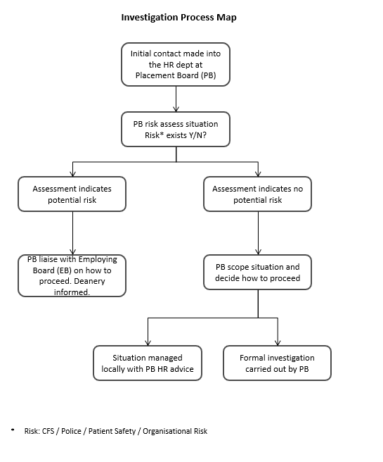

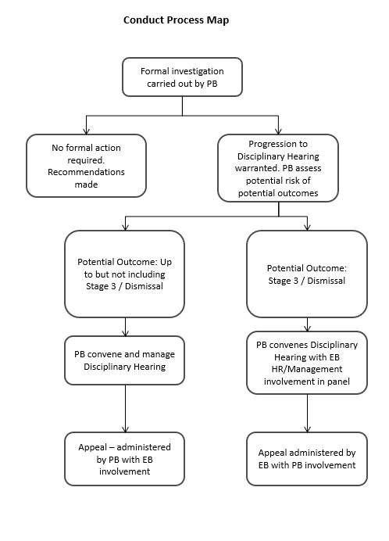

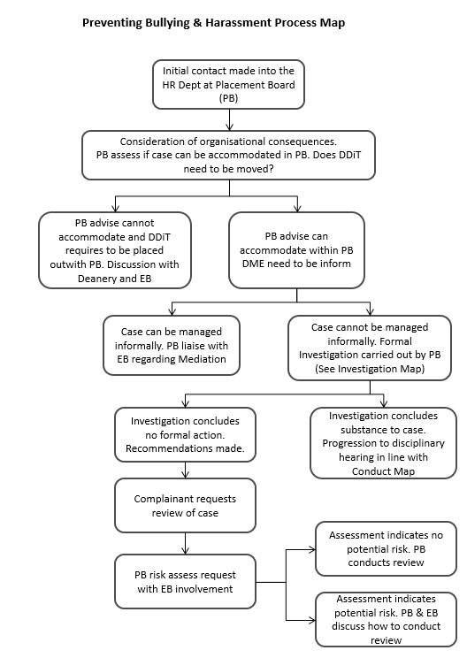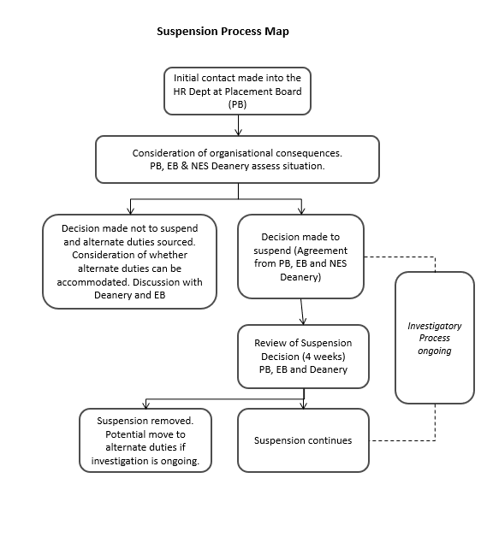

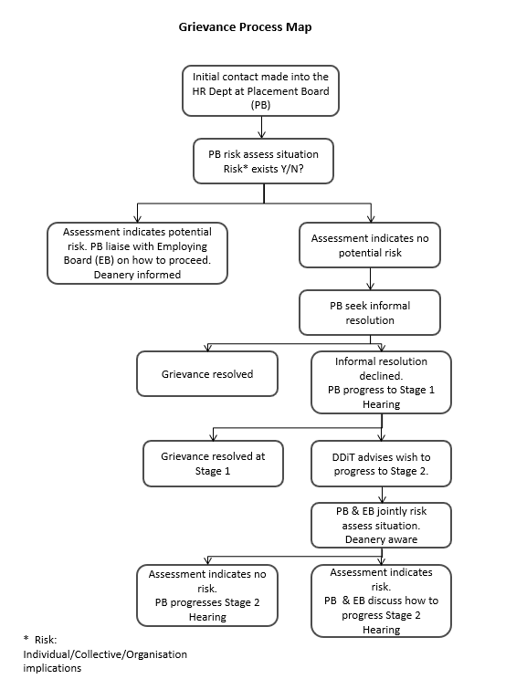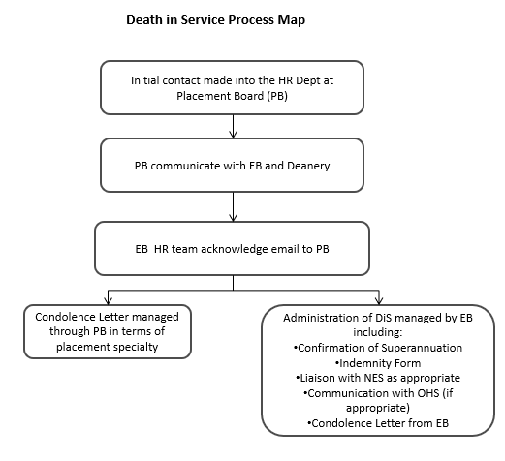

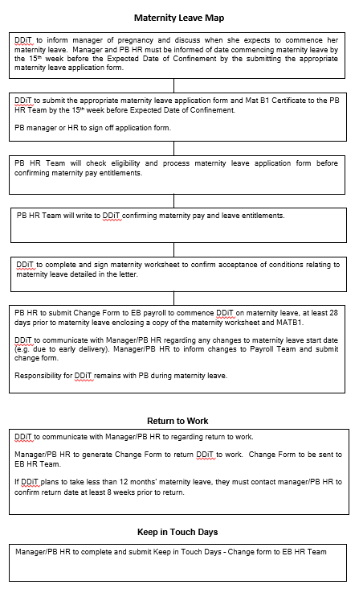

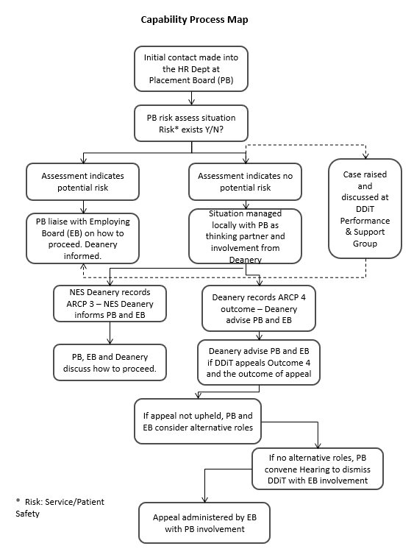

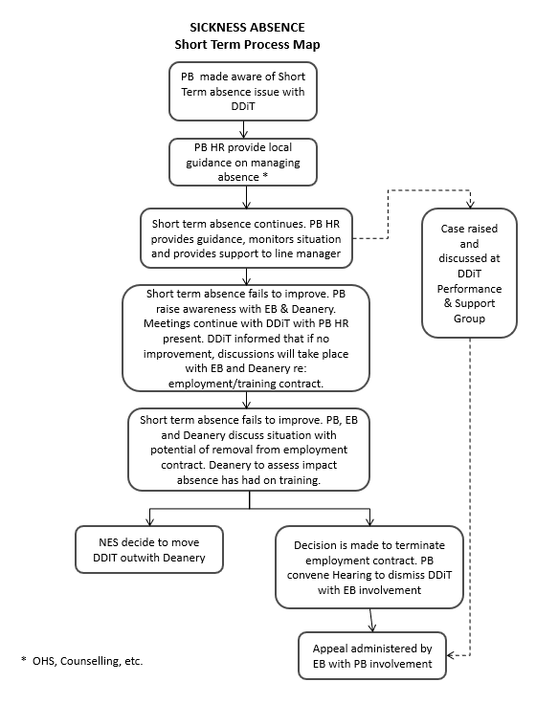
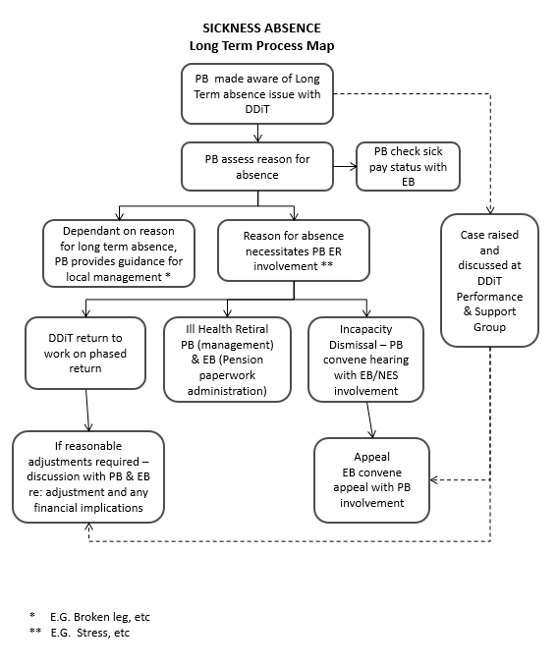

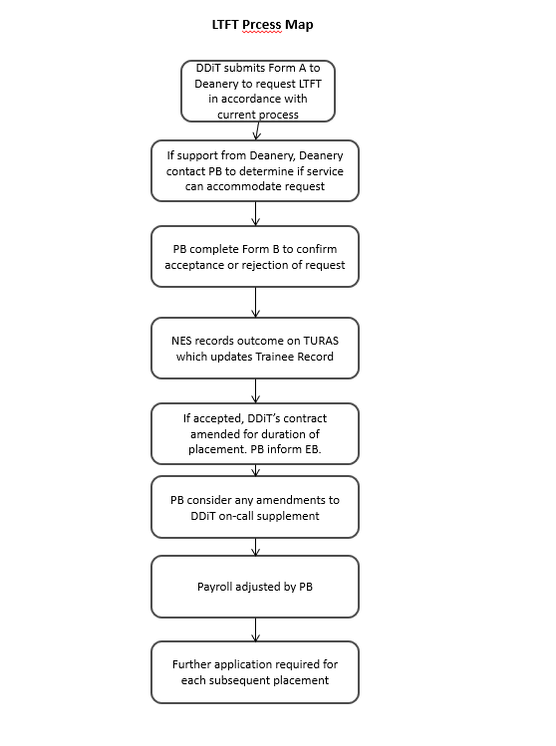

NES provides Tier 2 sponsorship
NES provides PVG checking service
NES Medical Director is the Responsible Officer for all trainees.
The Duty of Candour applies to the Board who is the provider of Health and/or Social Care which would therefore refer to the Health Board where the Doctor in Training is working.

