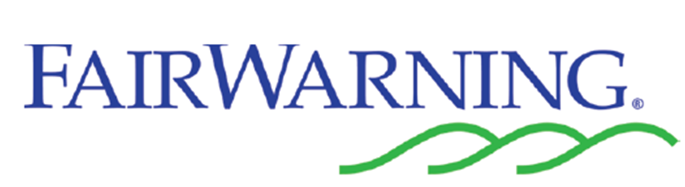

FairWarning is a new monitoring system which detects potential instances of unauthorised access to patient information held within electronic information systems. The rules regarding unauthorised access to patient information are not new. FairWarning simply allows us to flag up potential breaches more easily.
NHS Ayrshire & Arran takes confidentiality and its responsibilities under the Data Protection Act very seriously. Even if patient information is accessed with good intentions, staff looking at a clinical record or patient information out with their legitimate duties could face disciplinary action.
Examples of unauthorised access to patient information include:
- Accessing patient information where you do not have a legitimate reason for doing so: this might include accessing the records of colleagues, friends, your children, other family members or neighbours. This access may be malicious and / or simple curiosity. It may even be at the request of the individual. All represent unauthorised access and constitute a breach which will be flagged by the FairWarning system.
- Accessing the records of people of media interest: unauthorised or unnecessary examination of the records of people in the public eye – for example, footballers or sports stars, politicians, media personalities or criminals.
- Accessing your own records.
  - Using a log on given for work purposes to access your own records is in breach of:
    - National policy - Accessing Personal Information on Patients and Staff: A Framework for NHS Scotland
    - The Protecting Patient Confidentiality: NHS Scotland Code of Practice (see page 8)
  - You must make a Subject Access Request under the Data Protection Act if you want to access your own information - exemptions may need to be applied to an individual's right to access their own information, and for this reason access to your own records must go through the official process. If you only require minimal information such as to check the time of an appointment, you will not need to make a formal subject access request and can simply contact the service and ask rather than checking your own record.
  - Some websites are used to give patients direct access to their results and other data. Data on websites such as this are uploaded with the intention of allowing full access to the patient. Data entered on our patient information systems may contain information which is exempt from disclosure, and therefore unrestricted access cannot be allowed.
  - The Medical and Dental Defence Union for Scotland advise members not to access the records of individulas who are not patients, including their own - full article here.
- Logging on as someone else: using the login of another member of staff, even in the course of treating a legitimate patient, constitutes a breach of the NHS Ayrshire & Arran Appropriate Use of IT Facilities Policy and will be investigated accordingly.
Where a potential breach is identified, the staff member's line manager will be notified and asked to hold an initial conversation to determine whether the access in question was inappropriate. A document giving guidance for managers will be sent to each manager that is asked to query their staff member's access.
We know the vast majority of staff respect confidentiality and that unauthorised access to patient information is rare. FairWarning is an opportunity to provide an even higher level of assurance that patient information is safe with us.

